The Triskele | Aengus | Arawn | Brigid | Cailleach
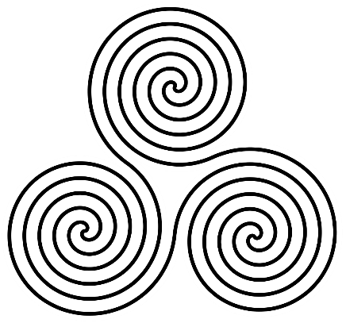 | 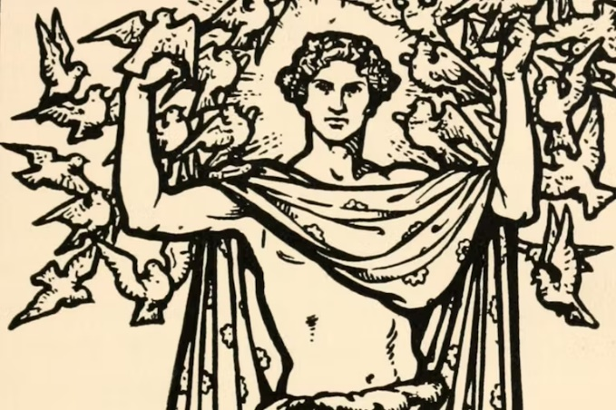 | 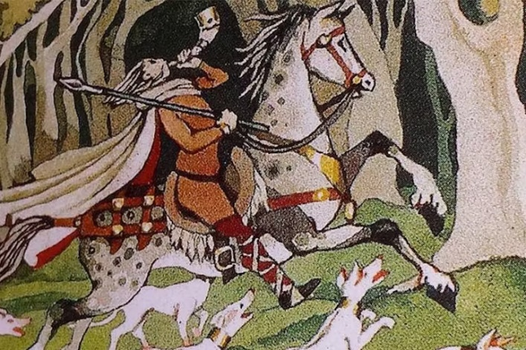 | 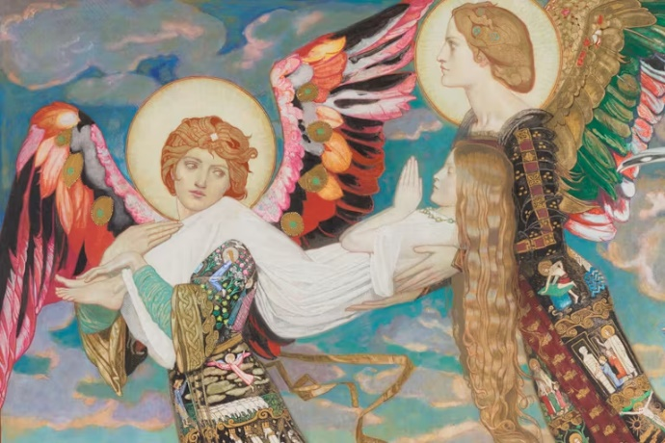 | 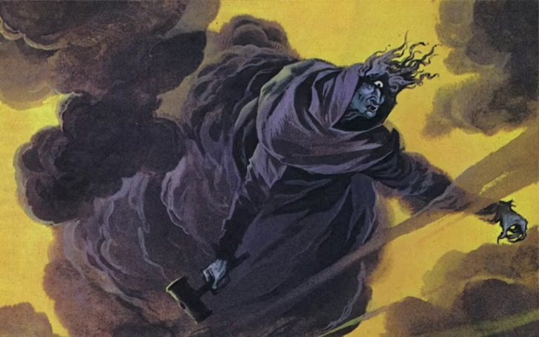
The Triskele (Symbol of Earth, Water and Sky) | Aengus was the Irish god of youth, love, and poetic inspiration. These attributes overlapped with one another, as youthful love often brought poetic inspiration to those within it. His cunning and poetic use of language often allowed him to get the better of his elders.  Aengus’ youth granted him certain powers over life and death, including the ability to resurrect the dead. He would bestow those he wished to resurrect with his breath of life, though the effects were not always permanent.  Aengus has the ability to shapeshift and used this ability to help him find a woman that had been transformed into a swan. His magic allowed him to transform kisses into birds—animals he favoured above all others. | Arawn is the Lord of Annwn, the Welsh Otherworld. Annwn is listed in different legends as an island off the coast of Wales, a cauldron or kingdom beneath the sea, or simply underground. Arawn is a just ruler, beloved by his court and his Queen, though he has competition for his rule.  Arawn appears as a skilled magician, able to switch his appearance for an entire year with the hero Pwyll. The magic is so effective that not even Arawn’s own wife knows of their switch. In addition to being a great ruler and skilled magician, Arawn appears as an adept hunter who loves sport, enough that every day his court goes hunting with his supernatural white-eared red-eyed dogs. | Brigid was a goddess full of contradiction. She was a goddess of healing, fertility, and motherhood, but also of passion and fire. Further complicating matters, Brigid was a goddess of serenity and water as well. When she was not protecting mothers and newborn children, Brigid inspired many of the writers and poets for which Ireland is internationally renowned. | Cailleach appears primarily as a veiled old woman, sometimes with only one eye. Her skin was deathly pale or blue, while her teeth were red and her clothes adorned with skulls. She could leap across mountains and ride storms. In the Manx tradition, the Cailleach was a shapeshifter capable of transforming into a giant bird.  Her tools of creation and destruction included her hammer, with which she was able to control storms and thunder. In some legends, she also controlled a well that would occasionally overflow and flood the land.  Despite this, she also cared deeply for animals both wild and domestic during the dark winter months. In all three Gaelic-speaking regions, she was the patron of wolves emboldened by winter hunger; in Scotland, she also served as a deer herder.  The Cailleach was also a goddess of grain, a key resource in surviving winter. The last sheath of grain harvested was dedicated to her, and used to begin the next planting season.

Ceridwen | Cernunnos | Dagda | Danu | Herne the Hunter
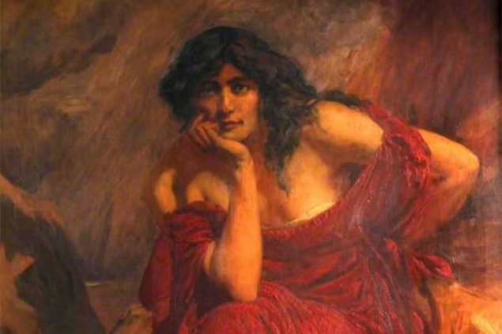 | 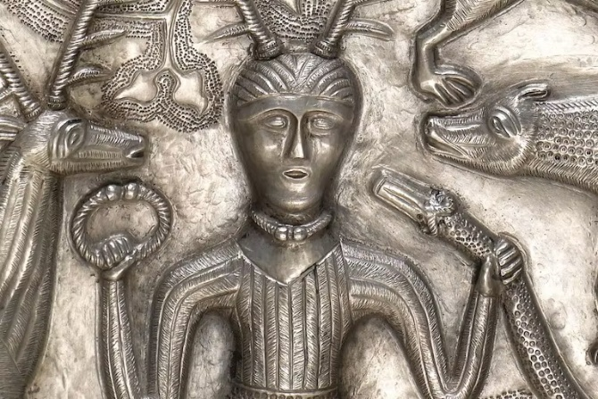 | 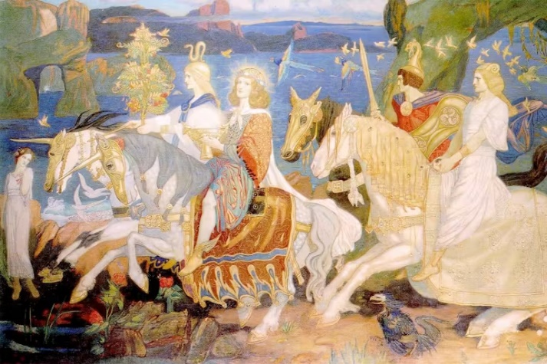 | 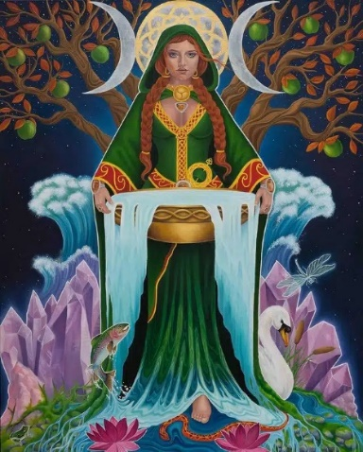 | 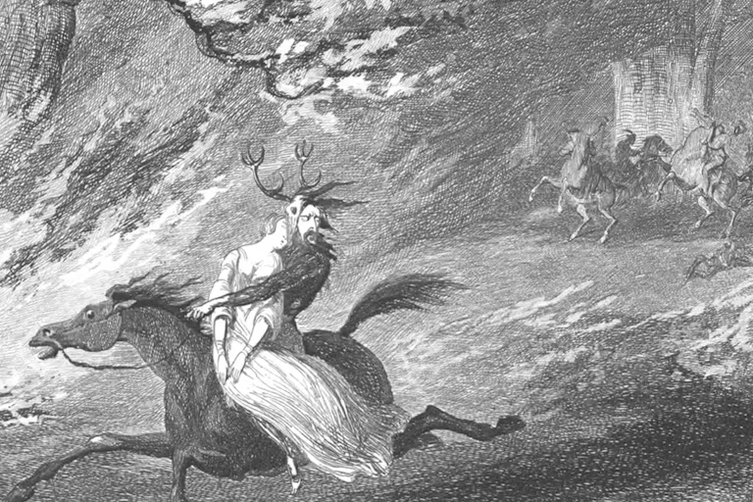
Ceridwen is a powerful Welsh sorceress, and one of the most powerful Goddess witches in Celtic mythology. A mother and a wise woman all at once, she is blessed by the gift of poetic wisdom, inspiration, and prophecy, called collectively Awen in Welsh lore. This power comes from her magical cauldron, where she brews great potions to help others. She has many of these abilities herself without the cauldron’s power. She also has a magical throne, from which she derives her sovereignty and some of her powers.  Potions brewed from her cauldron range in effect, such as changing the appearances of others, allowing the imbiber to shapeshift, or give the gift of Awen itself. Though her potions grant the gift, they are also quite dangerous. After the gift is given, a single drop of the potion has the power to kill. Ceridwen is thus careful with whom she gives her potions to, as she wishes no harm on others but knows that power comes with a price. | Cernunnos was a god of wild places, and often appeared as a bearded man with antlers.  Cernunnos was a god of the wild who ruled over pristine nature and uncivilized ways. Animals were his subjects, and free-growing fruits and vegetable his bounty. Classical depictions of the deity included gatherings of animals such as elk, wolves, snakes, and aurochs. Such gatherings were possible thanks to Cernunnos’ ability to bring natural enemies into peaceful communion with one another. This ability may have cast Cernunnos as a protector and provider amongst rural tribes and hunters.  Cernunnos may also have been a fertility god or god of life. | Dagda possessed immense skill that gave him dominion over a wide range of fields. He was not only the god of life and death, but of fertility and agriculture as well. The Dagda possessed many items that granted him further abilities. He could set the seasons to order with a strum of his harp, slay or resurrect a man with his club, or provide a generous feast with his cauldron. The Dagda was also a druid, and as such had mastery over all things magical and mystical. | Danu was the mother goddess. Danu was the source of the tribe's common heritage, as well as its nobility, unity, and power. As a goddess of sovereignty and power, Danu would grant gifts to rulers and those of noble birth. Though such gifts varied in value and substance, it is nevertheless clear that the kings, chiefs, and Ollam of the Tuatha Dé Danann all drew their power from her. The Tuatha Dé Danann were creative, crafty, and skilled; it has been theorized that Danu was the source of such talents.  As a mother goddess, Danu was believed to have suckled many of the gods and instilled in them a sense of wisdom. Given the migratory nature of the Tuatha Dé Danann, it has been speculated that she was a wind or earth goddess as well. All things in Ireland depended upon her blessings. | Herne the Hunter was a spectre that haunted Windsor Forest of Berkshire—now called Windsor Great Park. He haunted a particular tree, called Herne’s Oak, and terrorized the wildlife that inhabited the wood. He was known by the rattling of chains and the ghostly moans that preceded him, as well as the giant antlers upon his head.  Herne’s ghostly powers revolved around the decay of the natural world. He could cause a tree to wither and die with a single touch, and could bewitch cattle into producing blood instead of milk. In later legends, he possessed a horn and was accompanied by hounds. Sightings of Herne were believed to be evil omens that portended national disasters and significant deaths.  The character of Herne remains shrouded in mystery, in part due to his appearances rarely involving interaction. Herne was a notably cruel figure, possibly as a result of his death by suicide. His terrorizing of animals may have been related to this great shame.

Lugh | Morrigan | Nuada | Taranis
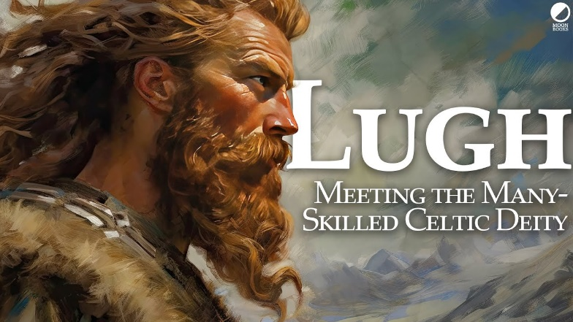 | 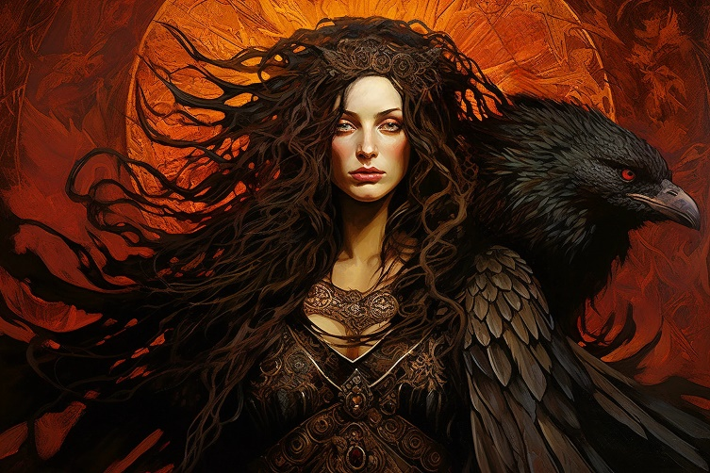 | 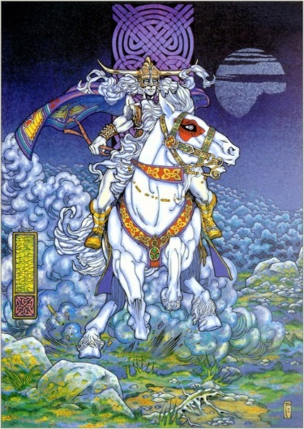 | 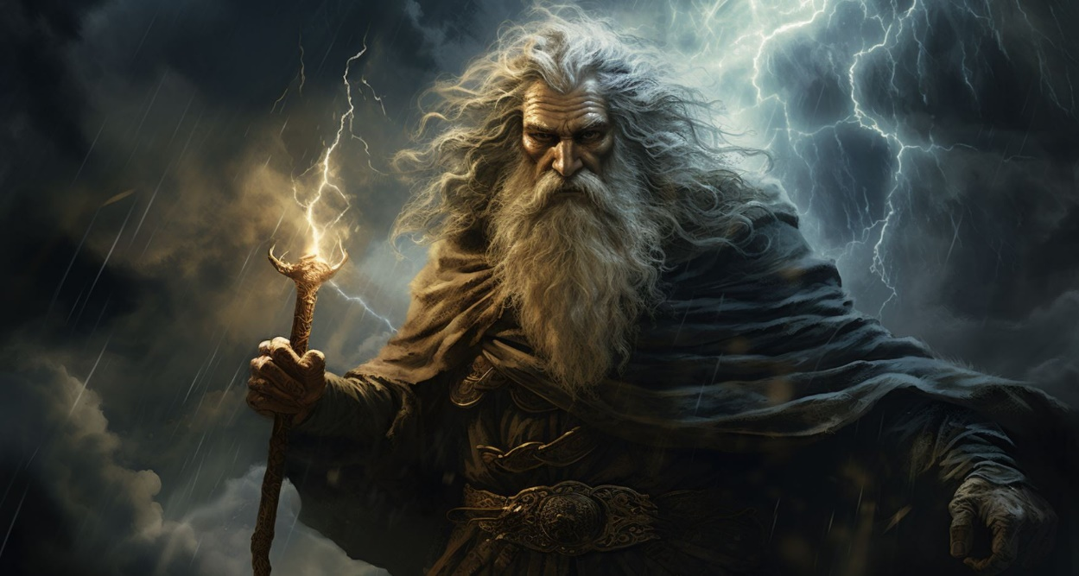
Lugh was a master of many talents. As the god of oaths, he held domain over rulers and nobility. He also served as the god of justice in its many forms; his judgement was often swift and without mercy. In what may seem like a contradiction, Lugh was also a trickster who was willing to lie, cheat, and steal to overcome his opponents.  As son of both the Tuatha Dé Danann and Fomorians, Lugh had a unique heritage. Such a background assisted him in inventing a number of notable Irish games, including horse-racing, sports, and fidchell, the Irish precursor to chess. | Morrigan appears as both an individual and as three goddesses acting under a single name.  In most cases, Badb, Macha, and Nemain are named as the Morrígan. Badb in particular is associated with the Morrígan’s appearance as a raven on the battlefield. These goddesses are also sometimes listed as sisters of the Morrígan.  The goddesses could also act independently of each other. In the Táin Bó Cúailgne, Nemain and Badb, two of the goddesses who make up the Morrígan, screech out to the men of Ireland under cover of night. The sound of their calls is so terrifying that 100 men die of fright. The shriek of the Morrígan was a horrible omen of misfortune to come. | Nuada was a keen hunter and fisher, one of the most skilled among his people. A sensible ruler, he saw the potential in all members of his court. Generous and impartial, Nuada made fair laws for his people to obey, and he followed those laws himself, even when they proved disadvantageous. He possessed one of the Four Treasures of the Tuatha dé Danann, a sword that, once drawn, no one could escape from or defend against. | Taranis was a powerful deity, commanding the storms which terrified early man. He was a protector and leader of the gods and, according to the Romans, this made him worthy of human sacrifice.  Taranis wielded a powerful thunderbolt as a weapon, not unlike a spear, and his symbol was a wheel, one of the most sacred Celtic symbols found across Europe. The wheel represented mobility, one of the strengths of the ancient Celts, and may have represented just how quickly a storm could catch ancient humans unprepared.

