Roman Pantheon
Roman Pantheon
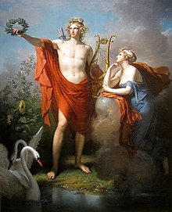 | 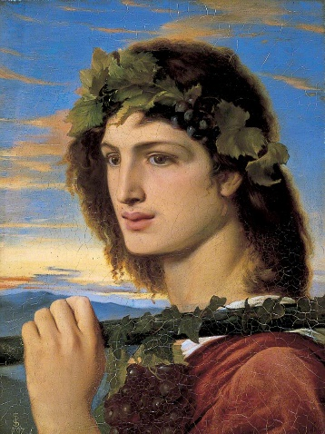 | 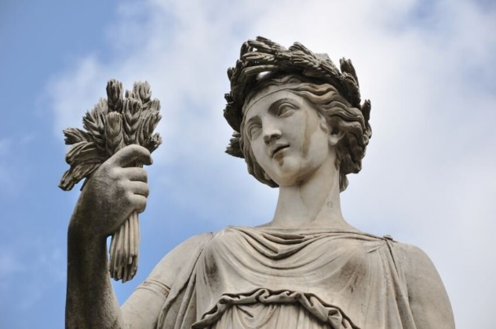 | 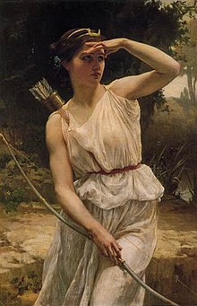 | 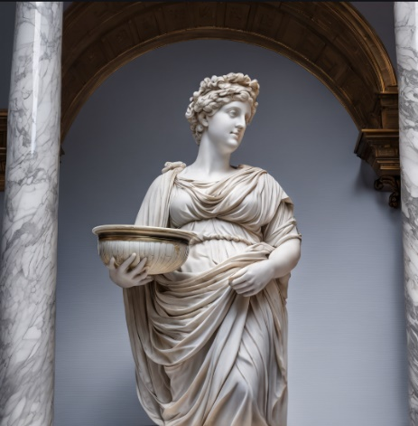
Apollo is the ultimate bringer of law, reason, and peace. He oversaw the creation of civil constitutions and maintained the social order. He was also the patron of many important cities, including Delphi and Rome.  Apollo’s role as the preserver of the body politic was mirrored in his role as the healer of bodies. Via his son Asclepius, Apollo gave humanity the gift of medicine. He also served as the patron of doctors.  Just as Apollo cured disease, he also caused it. Wielding a silver bow, he fired plague arrows at all who crossed him, including the Achaeans during the battle of Troy. Apollo usually carried a lyre, his favorite musical instrument, and was often portrayed as a beardless youth. Described as “shining” and “the sun,” he was sometimes depicted with rays of light emanating from his body. This literal and metaphorical light symbolized the enlightenment that Apollo bestowed upon his followers. | Bacchus, like Dionysus, was usually imagined as a young man wearing a crown and carrying a thyrsus (a stem of narthex or fennel topped by a pinecone). Vines and grapes were also important attributes of Bacchus.  Bacchus was accompanied wherever he went by an entourage of revellers and beasts. This entourage included frenzied worshippers known as maenads, as well as satyrs and pans—creatures that were half-human and half-animal.  Bacchus was the God of wine and ecstasy. | Ceres’ most recognizable attributes were adapted from those of the Greek Demeter. She was perhaps most readily distinguished by the corona spicea, a crown or wreath made of ears of corn or wheat, which encircled her blonde, grain-colored hair. She was the Goddess of agriculture.  Ceres often carried a torch, or even multiple torches; the poet Ovid, for example, described Ceres with a lighted torch in each hand as she searched for her kidnapped daughter Proserpina. | Diana, wielding a bow and golden arrows, roamed the wilderness seeking adventure and hunting game. She usually wore a chiton, a short tunic typically worn by males, because it allowed her to range freely throughout the woods. Diana also wore a cloak, boots, and a belt with a jewelled clasp.  Though she often preferred solitude, Diana would occasionally seek the companionship of forest and water nymphs, such as her partner Egeris. | Juno’s attributes were heavily influenced by those of her Greek counterpart, Hera. Juno, like Hera, was imagined as the archetypal queen; she usually wore a crown and sometimes held a sceptre or a type of libation bowl called a patera. Her favorite animal was the peacock, which frequently accompanied her in literature and art.

Roman Pantheon
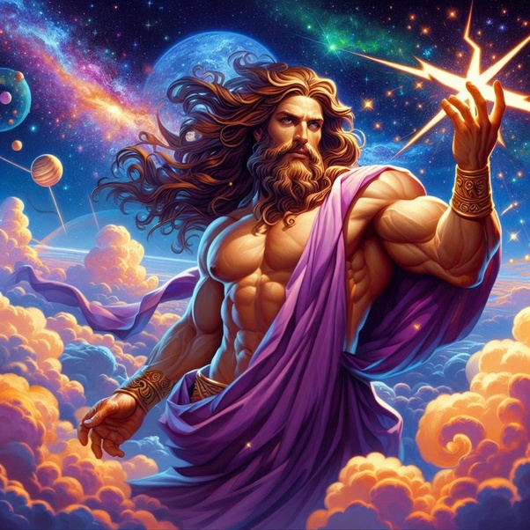 | 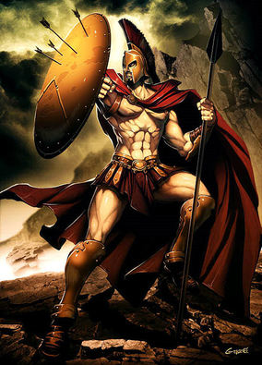 | 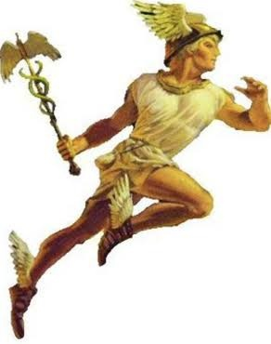 | 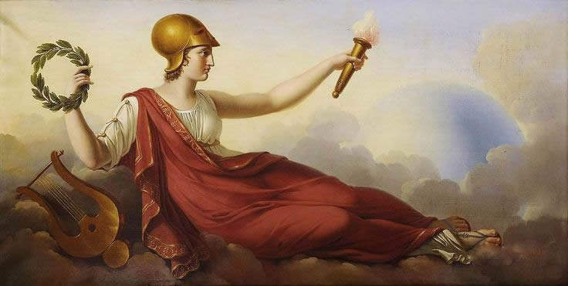 | 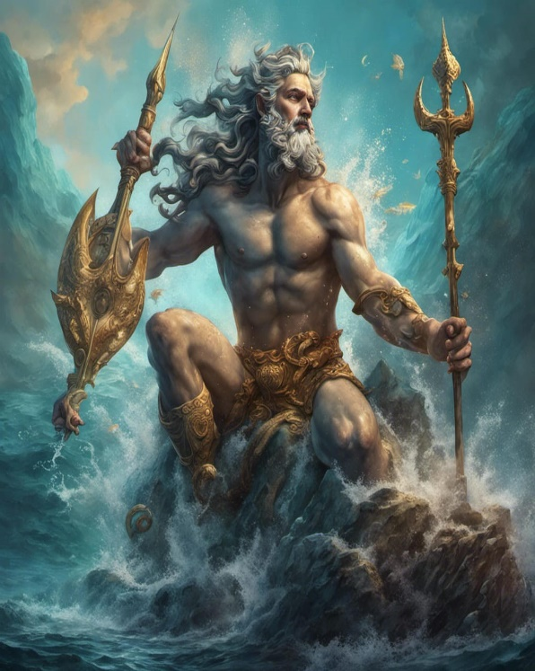
Jupiter’s most notable attribute was lightning or the thunderbolt, which he wielded as the god of the sky and storms. Jupiter also held a sceptre (sceptrum in Latin), a symbol of his sovereignty and power. In literature and art, he was frequently associated with the eagle.  Jupiter was often shown riding a quadriga, or four-horse chariot. He was also associated with white animals: his chariot, for example, was drawn by white horses, and he received white bulls as sacrificial victims. | Mars controlled war and the passions that fuelled it. He was represented both as a fully mature male with a beard and curly hair, and as a youth with smooth cheeks. His shield was often adorned with the gorgoneion, a medusa head that was thought to ward off evil. His weapon was the spear, which would be wrapped in a laurel to symbolize peace. This symbolism spoke to Mars’s status as the god who brought peace through war. | Mercury, as the chief messenger of the gods, controlled the movement of all things—goods, ideas, words, and people. He wore winged shoes and flew with the help of a winged helm that Vulcan, the god of forge and fire, had fashioned for him. This winged helm soon became synonymous with the messenger god. Mercury was swift and clever, and his knowledge of major events often bordered on foresight. | Minerva, the wisest of all gods and goddesses, had a calculating mind that she used to achieve her aims. The most chaste of Roman deities, Minerva spurned the advances of men and gods alike in order to retain her virginal purity.  As a goddess of peace and the civilized arts, Minerva sometimes wore a chiton—a set of long robes worn to floor-length by a lady, and knee-length by men—and a crown of laurels. As the fierce goddess of warfare, Minerva would also wield a spear and don a Roman general’s armour, complete with a soldier’s helm and a small shield. Most depictions of the goddess portrayed her in this latter attire. | Neptune controlled all waters, from the smallest streams and springs to the largest well-known bodies of water—namely, the seas. Neptune made the Mediterranean Sea his domain, and lived in a golden palace beneath the waves with his consort Salacia and his loyal sons.  Neptune could also summon winds and storms. By roiling the seas and delivering crushing waves, Neptune sunk many ships and sent many sailors to watery graves. While he was truly mighty in his own domain, Neptune’s power waned the further he was from the seas.  Neptune was thought to wield a trident—a three-pronged thrusting weapon used by Mediterranean fisher people for centuries.

Roman Pantheon
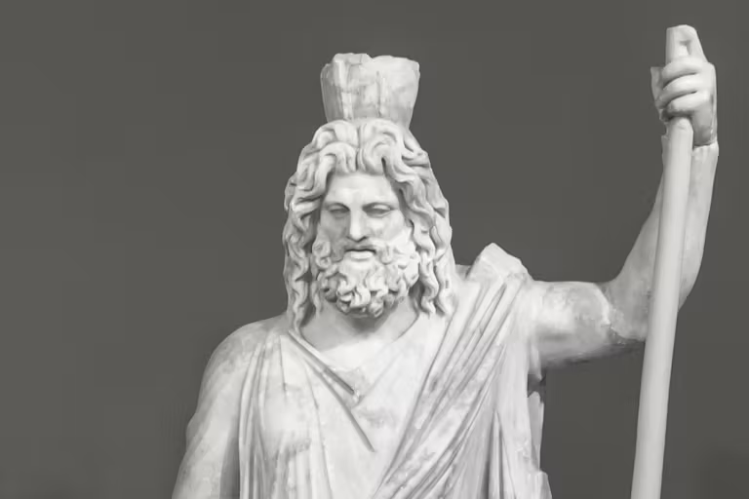 | 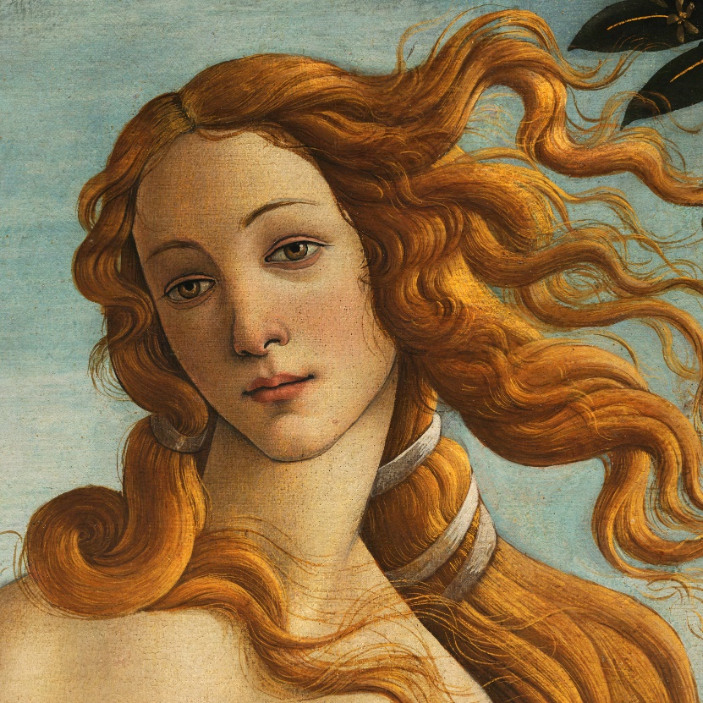 | 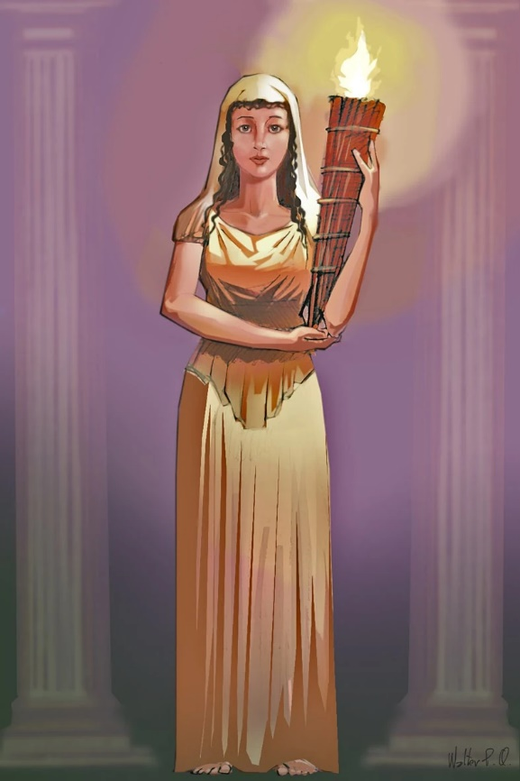 | 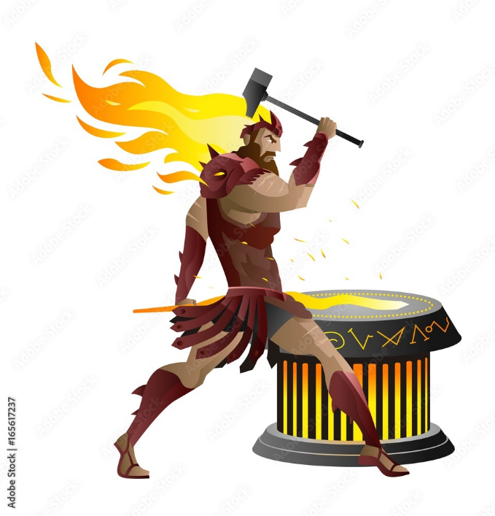
Pluto was the lord of the subterranean underworld, which in Roman mythology served as the resting place of departed souls. He lived underground in a gloomy palace, and seemed to have little interest in the world of men. Likewise, Pluto seldom involved himself in godly affairs. He rode a chariot, carried a staff, and was often depicted wearing a warrior’s helm. Pluto was often accompanied by Cerberus, a three-headed hound that served both as his pet and guardian of the underworld. | Venus, as the goddess of love and sex, possessed the ability to make mortals and gods fall madly in love. Venus’ chief weapons were her charm and erotic appeal, and, in her mythological tradition, many fell victim to them.  Depictions of Venus were often found in domestic settings. In many of her appearances, she was accompanied by symbols such as the rose—a symbol of fertility and sexual passion. Additionally, she was often featured with a crown of myrtle (an evergreen brush with white flowers). This crown quickly became one of her chief symbols. Sea shells were another common motif; these shells served both as a reference to Venus’ birth at sea and as yet another of Venus’ many erotic symbols. | Vesta oversaw the home and family life, ensuring the sanctity of the house and securing its tranquillity. Despite her seeming lack of mythological presence, Vesta’s enormous power over family, marriage, and children protected the moral integrity of all Romans. For this reason, all prayers and sacrifices began and ended with devotions to Vesta. | Vulcan. From metallurgy and smithing to arms and jewellery making, Vulcan was a master of the forge. He was believed to have created the strongest and most sophisticated items of ancient lore, including Jupiter’s lightning bolts and Mercury’s winged helm.  Vulcan’s deformed leg made him something of a pariah amongst the gods. It was this imperfection that compelled Vulcan to seek perfection in his craft.

