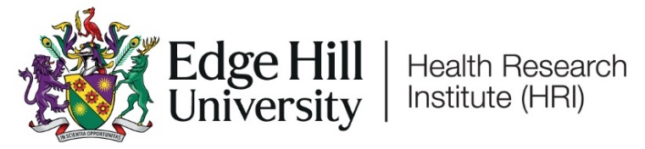

Health Research Institute Showcase
Connecting, collaborating, communicating
Thursday 19th September 2024, H1, Faculty of Health, Social Care and Medicine

9:00 | ARRIVAL & REGISTRATION
9:30 | Welcome & Introduction | Dr John Cater, EHU Vice-Chancellor & Professor Rowan Pritchard-Jones, Conference Chair
9:40 | Overview of Health Research Institute | Professor Greg Irving, HRI Director
9:50 | Keynote Talk - NIHR Health & Social Care Delivery Research programme – a Programme Director’s view | Professor Kathy Rowan, NIHR Director of Health & Social Care Delivery Research Programme
10:35 | BREAK: Poster presentations / Networking
11:05 | Cheshire and Mersey Integrated Care Board (ICB) – Strategies overview | Professor Terry Jones
11:15 | Oral Presentations
11:45 | Lancashire and Cumbria Integrated Care Board (ICB) – Strategies overview | Professor Sarah O’Brien
11:55 | Oral Presentations
12:25 | LUNCH BREAK: Poster presentations / Networking  Facilities tours (optional): Clinical Skills and Simulation Centre (CSSC) inc Counselling rooms & Nutrition kitchen space, and Psychology Labs
13:15 | Parallel Sessions – Oral Presentations (H1, H021, H201, H242, H243)
14:15 | Keynote Talk - Introduction and Guide to the NIHR Applied Research Collaboration North West Coast | Professor Mark Gabbay, Director of Applied Research Collaboration North West Coast (ARC NWC), NIHR
15:00 | BREAK: Poster Presentations / Networking
15:20 | Greater Manchester Integrated Care Board (ICB) – Strategies overview | TBC
15:30 | Oral Presentations
16:00 | Prizes for best oral presentation, best poster presentation, best intern poster presentations and Early Career Researcher prize.
16:10 | Thanks, final thoughts and close  Facilities tours (optional): Sport Science Laboratories & Sports Therapy Clinics, Computer Science, Biomedical Science Research, and Psychology Labs | Professor Rowan Pritchard-Jones and Professor Greg Irving

Please note: There will be photography happening throughout the event. If you do not wish to be on any photos, please make yourself known to the event team

