# Ingredients

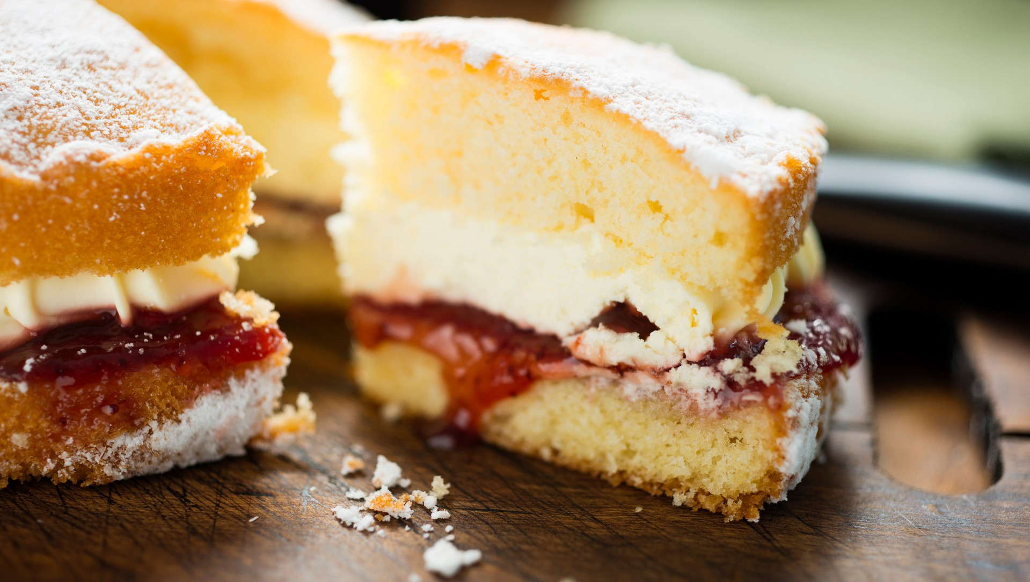

***VANILLA CAKE***

**COOK TIME: 2HRS 30MINS / SERVINGS: 12**

**For the cake**

250g baking **butter** 250g caster sugar 1 tsp vanilla extract

5 large **eggs**, cracked into a jug 85g plain **flour**

100g full-fat Greek **yoghurt** 250g self-raising **flour** 3tbsp **semi-skimmed milk**

¼ tsp salt



You can use

gluten-free flour

You can use

non-dairy yoghurt, milk and butter

Communal

bake

**For the filling**

Strawberry jam

250g unsalted **butter**

500g icing sugar

2 tsp vanilla extract

**For the decoration** Sprinkles or anything else of your choosing

1. Heat oven to 160C/140C fan/gas 3. Grease a round, deep 20cm tin, then line the base and sides with non-stick baking paper.

**How to cook**

1. Using electric beaters or a table top mixer, beat the butter, sugar, vanilla and

¼ tsp salt together until pale and fluffy, then pour in the eggs, one at a time, giving the mix a really good beating before adding the next.

1. Add 1 tbsp of the plain flour if the mix starts to look slimy rather than fluffy. Beat in the yogurt. Mix both the flours; then, using a large spoon, fold them into the batter, followed by the milk.
2. Spoon the mix into the tin and bake for 1 hr 20 mins or until well risen and golden – a skewer inserted into the middle should come out clean.
3. Whilst the cake is cooling make the buttercream. Cut the butter into cubes and place in a bowl and beat until the butter becomes softer and lighter in colour. Add in the vanilla extract and 2 tbsp of the icing sugar at a time until the icing is smooth.
4. Once the cake has cooled slice the cake in half and spread a medium amount of buttercream in the middle and strawberry jam to your liking. Place the other half of the cake on top.
5. Spread the rest of the buttercream on the top of the cake and decorate to your choosing.

**Per serving**

**Vanilla cake**

**kcal**

**399**

**fat**

**21g**

**saturates**

**12g**

**carbs**

**48g**

**sugars**

**27g**

**fibre**

**1g**

**protein**

**6g**

**salt**

**0.31g**

**Nutritional Info**

**To book onto our cookery sessions + other events visit**

**ehu.ac.uk/studentlifeportal**

|  |  |  |  |  |  |  |  |  |
| --- | --- | --- | --- | --- | --- | --- | --- | --- |
|  |  |  |  |  |  |  |  |  |
|  |  |  |  |  |  |  |  |  |

# Ingredients

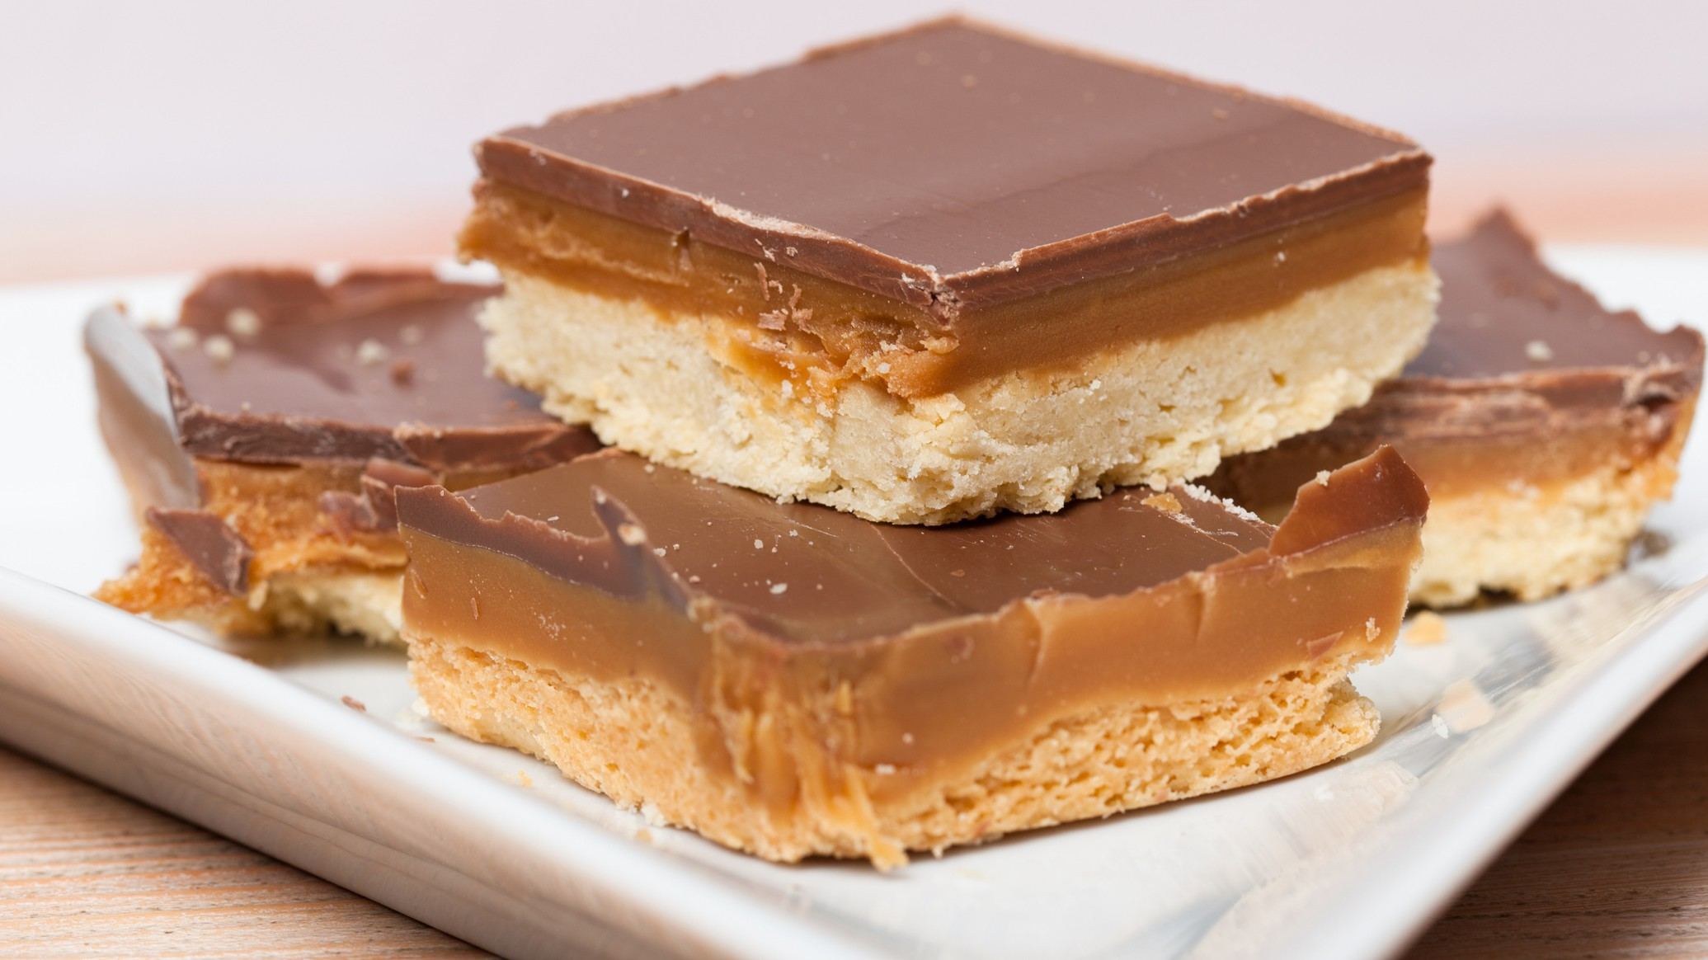

***MILLIONAIRE SHORTBREAD***

**COOK TIME: 55MINS / SERVINGS: 24**

**For the shortbread** 250g plain **flour** 75g caster sugar

175g **butter**, softened

# For the topping

200g plain or milk **chocolate**, broken into pieces

**For the caramel**

100g **butter**

100g light muscovado sugar 397g can condensed **milk**



You can use

gluten-free flour

You can use

non-dairy milk, butter & chocolate

Communal

bake

1. Preheat the oven 180C/160C fan/gas 4.

**How to cook**

1. Lightly grease and line a 20-22cm square or rectangular baking tin with a lip of at least 3cm.
2. To make the shortbread, mix 250g plain flour and 75g caster sugar in a bowl. Rub in 175g softened butter until the mixture resembles fine breadcrumbs.
3. Knead the mixture together until it forms a dough, then press into the base of the prepared tin.
4. Prick the shortbread lightly with a fork and bake for 20 minutes or until firm to the touch and very lightly browned. Leave to cool in the tin.
5. To make the caramel, place 100g butter or margarine, 100g light muscovado sugar and the can of condensed milk in a pan and heat gently until the sugar has dissolved. Continually stir with a spatula to make sure no sugar sticks to the bottom of the pan.
6. Turn up the heat to medium high, stirring all the time and bring to the boil, then lower the heat back to low and stirring continuously, for about 5-10 minutes or until the mixture has thickened slightly. Pour over the shortbread and leave to cool.
7. For the topping, melt 200g plain or milk chocolate slowly in a bowl over a pan of hot water. Pour over the cold caramel and leave to set.
8. Once set, cut into squares or bars with a hot knife.

**Per serving**

**Millionaire shortbread**

**kcal**

**248**

**fat**

**13g**

**saturates**

**8g**

**carbs**

**29g**

**sugars**

**21g**

**fibre**

**1g**

**protein**

**3g**

**salt**

**0.3g**

**Nutritional Info**

**To book onto our cookery sessions + other events visit**

**ehu.ac.uk/studentlifeportal**

|  |  |  |  |  |  |  |  |  |
| --- | --- | --- | --- | --- | --- | --- | --- | --- |
|  |  |  |  |  |  |  |  |  |
|  |  |  |  |  |  |  |  |  |

**Ingredients**

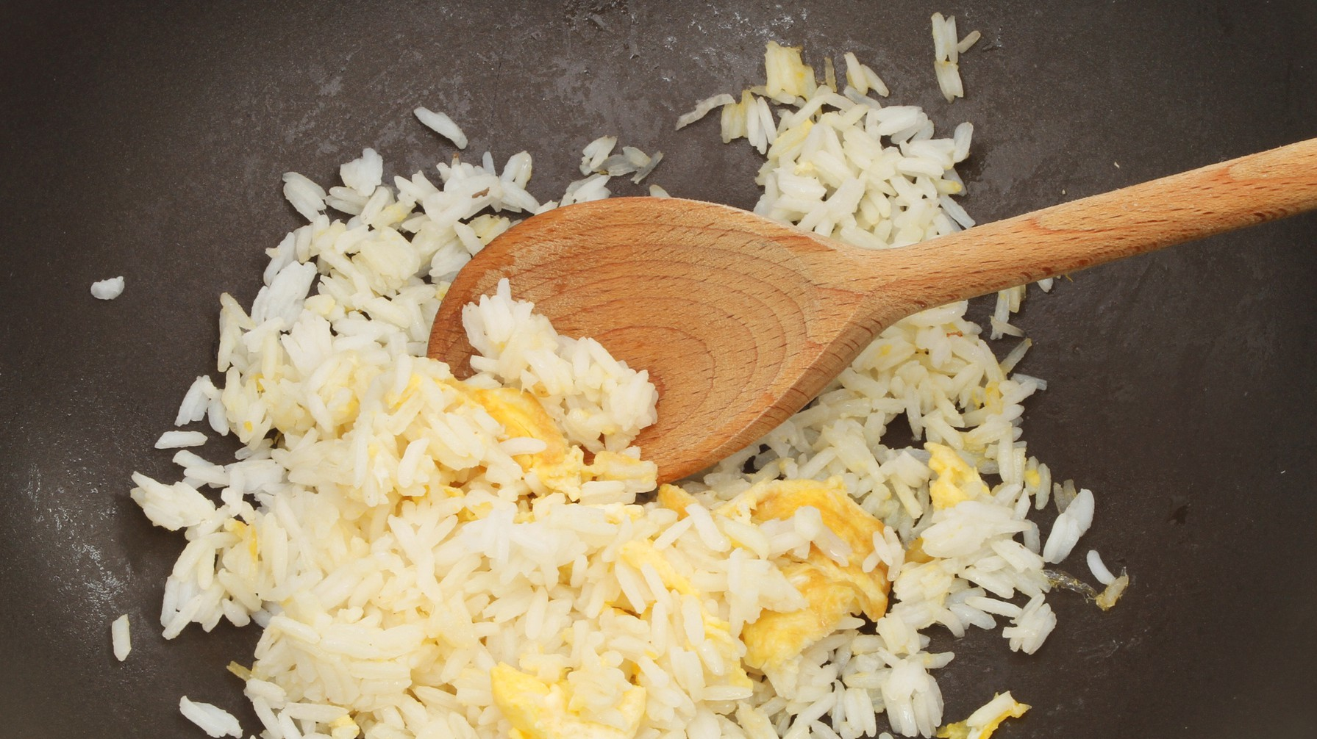

***EGG-FRIED RICE***

**COOK TIME: 15MINS / SERVINGS: 3**

190g white long-grain rice 2 **eggs**

Pinch of salt

3 tbsp olive oil

4 tbsp **sesame oil** (optional can just use olive oil if you prefer)

3 tbsp **soy sauce**

Super speedy

recipe

Going Global

recipe

Super Saver

Recipe

1. Place the rice in a saucepan over a medium heat and cover with double the amount of water. Boil the rice until al-dente (soft on the outside but a little bite left on the the inside). Strain and set to one side to slightly cool.

**How to cook**

1. Crack the eggs into a small bowl, add the salt and beat with a fork. Add the olive oil to a frying pan and place over a medium heat. Once the oil is hot add the beaten egg and stir to break the egg up into chunks.
2. Add in the cooked rice and sesame oil and stir until both egg and rice are coated in the oil. Make sure the rice is hot enough and until it starts to look crispy in places. Add the soy sauce and stir until everything is nicely cooked and the rice doesn’t look so white.

**Per serving**

**Egg-Fried RIce**

**kcal**

**184**

**fat**

**7g**

**saturates**

**2g**

**carbs**

**22g**

**sugars**

**0.3g**

**fibre**

**0.5g**

**protein**

**8g**

**salt**

**3g**

**Nutritional Info**

**To book onto our cookery sessions + other events visit**

**ehu.ac.uk/studentlifeportal**

|  |  |  |  |  |  |  |  |  |
| --- | --- | --- | --- | --- | --- | --- | --- | --- |
|  |  |  |  |  |  |  |  |  |
|  |  |  |  |  |  |  |  |  |

# Ingredients

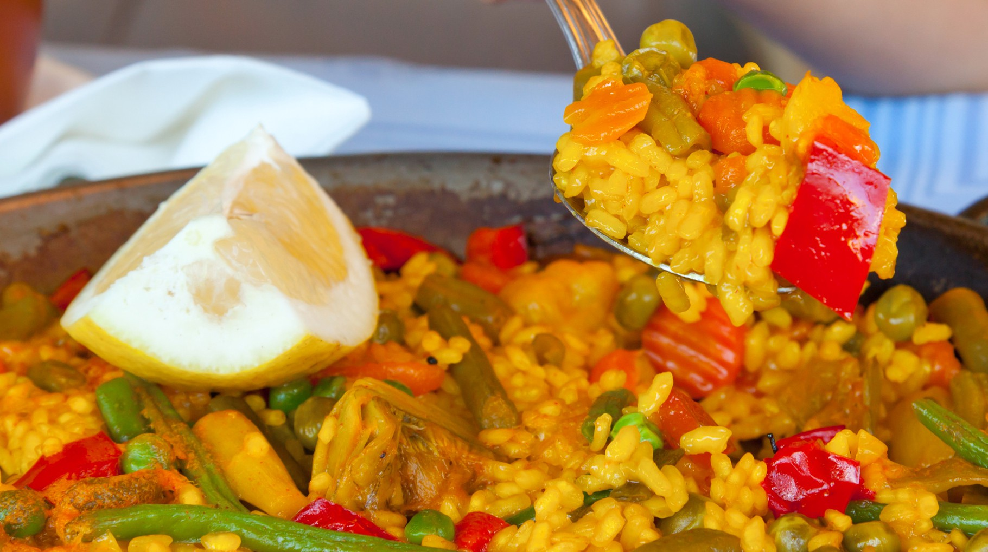

***VEGETABLE PAELLA***

**COOK TIME: 45MINS / SERVINGS: 4**

2 tbsp oil

1 chopped red onion 1 sliced pepper

1 sliced courgette

1 tbsp garlic granules

2 tsp oregano

1 tbsp smoked paprika 300g long-grain rice



Vegetarian /

Vegan friendly

Super Saver

Recipe

Communal

bake

400g tin chopped tomatoes

1 vegetable stock pot, made up to 800ml

1 lemon, cut into wedges

1. Heat oil over a medium-high heat and fry the onion and peppers until soft. Add the courgette and fry for a further 5 mins.

**How to cook**

1. Stir in the garlic, oregano, and paprika and fry for another 2 mins. Once spices have cooked, add in the washed dried rice. To wash rice put it in a bowl of water and swirl til it’s cloudy, then rinse the rice until the water you pour out the bowl runs clear. Then stir to coat it in the spices and herbs.
2. Add chopped tomatoes and vegetable stock and mix, then bring to a simmer. Turn down the heat to medium/low once simmered and add a lid to the pan. Cook for 15 mins without being tempted to stir.
3. Remove the lid and check the liquid has reduced and the rice is tender. Simmer uncovered for a further 5 mins if some liquid is present or if the rice is not soft. If this is the case, add 150ml water and cook for 5 mins more with the lid on.
4. Finally, take the paella off the heat and stir. Serve with the lemon wedges to squeeze over the paella.

**Per serving**

**Vegetable Paella**

**kcal**

**396**

**fat**

**8.8g**

**saturates**

**1.6g**

**carbs**

**68.9g**

**sugars**

**8.2g**

**protein**

**8.5g**

**Nutritional Info**

**To book onto our cookery sessions + other events visit**

**ehu.ac.uk/studentlifeportal**

|  |  |  |  |  |  |  |
| --- | --- | --- | --- | --- | --- | --- |
|  |  |  |  |  |  |  |
|  |  |  |  |  |  |  |

# Ingredients

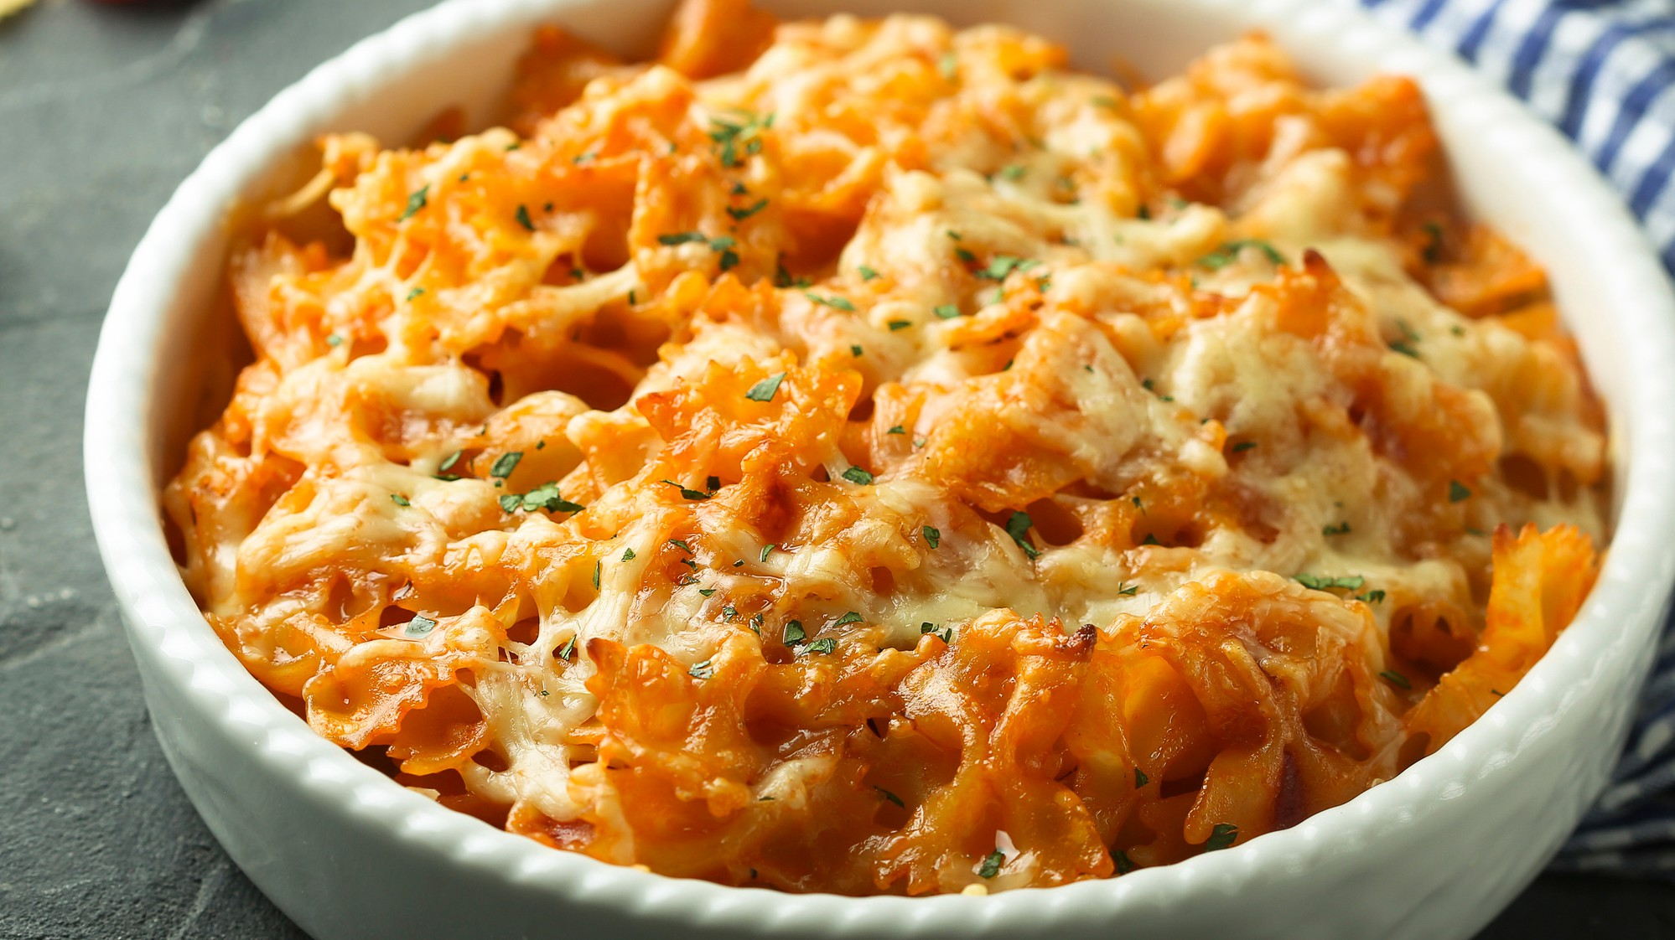

***PASTA BAKE***

**COOK TIME: 1HR10MINS / SERVINGS: 6**

1tbsp olive oil

1 red onion, diced

1 carrot, peeled and diced

1 **celery** stalk, diced

2 garlic cloves, finely sliced 1tbsp balsamic vinegar 1tbsp dried oregano

2 x 400g tins chopped tomatoes



Vegetarian /

Vegan friendly

Super Saver

Recipe

Communal

bake

500g penne pasta

200g mature cheddar **cheese**, grated

1. In a large pan, heat the oil over a medium heat. Fry the onion, carrot and celery for 5 mins, or until softened. Add in the garlic and cook for a further 2-3 mins.

**How to cook**

1. Turn the heat up and add in the balsamic vinegar and bubble until reduced. Add the oregano, tinned tomatoes and 350ml water and bring to the boil. Turn down the heat and simmer for 20 mins, then remove from the heat.
2. Meanwhile, bring a pan of salted water to the boil and cook the penne following the pack instructions. Preheat the oven to gas 6, 200°C, fan 180°C.
3. Use a handheld blender to blitz the sauce until smooth then season well. Stir in the drained pasta then transfer everything to a large baking tin. Top with the cheese and bake in the oven for 15 mins, or until golden and the sauce has reduced

*Freezing and defrosting instructions*

This recipe is freezable. To defrost, leave for an hour at room temperature. Bake at 200°C/400°F/Gas Mark 6 for 30 minutes or until heated through.

**Per serving**

**Pasta Bake**

**kcal**

**493**

**fat**

**15g**

**saturates**

**8g**

**carbs**

**69g**

**sugars**

**9g**

**protein**

**20.8g**

**Nutritional Info**

**To book onto our cookery sessions + other events visit**

**ehu.ac.uk/studentlifeportal**

|  |  |  |  |  |  |  |
| --- | --- | --- | --- | --- | --- | --- |
|  |  |  |  |  |  |  |
|  |  |  |  |  |  |  |

# Ingredients

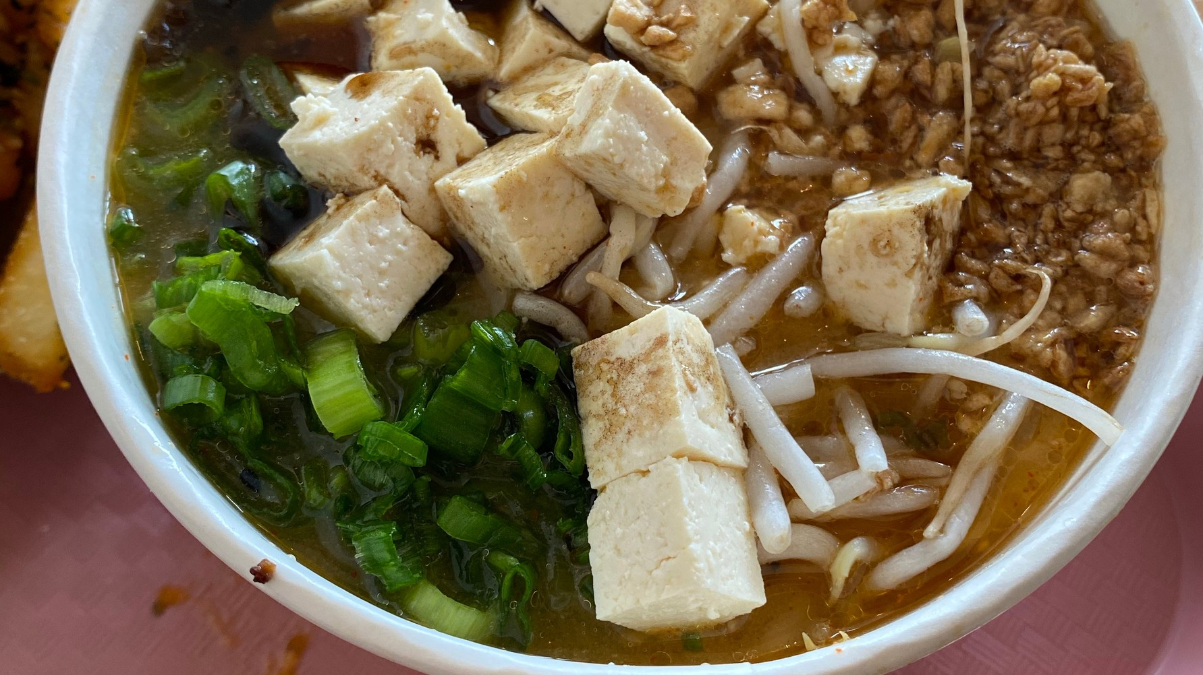

***VEGAN RAMEN***

**COOK TIME: 25MINS / SERVINGS: 2**

2 garlic cloves

Thumb-sized piece of ginger 1 tbsp **miso paste**

15g shiitake mushrooms 1l vegan stock (vegetable stock cube)

2 tbsp **soy sauce** 200g firm tofu (cut into cubes)



Vegetarian /

Vegan friendly

Super Saver

Recipe

Going Global

recipe

1 tbsp cornflour

1 tbsp vegetable oil

100g (2x nests) ramen or rice noodles

1 pak choi, quartered

2 spring onions

1 carrot, peeled and cut into fine matchsticks

**Sesame oil** (optional, to serve)

1. Crush the garlic, then put in a saucepan with the chopped ginger, miso paste, mushrooms, stock and soy sauce. Bring to a gentle simmer, cover and bubble for 5 minutes until everything is soft. Strain into a clean pan, discard everything left in the strainer.

**How to cook**

1. Toss the tofu slices in the cornflour and heat the oil in a frying pan. Fry for a few minutes on each side.
2. Cook the noodles for the correct amount of time, drain and leave in the pan with a little cooking water, so they don’t stick together.
3. Add the pak choi and the whites of the spring onions to the broth and gently reheat for 1-2 mins until the greens have just wilted.
4. Divide the noodles between two deep bowls, ladle over the broth and vegetables. Top with the tofu, carrot, ginger, green parts of the spring onions and a drizzle of sesame oil (optional)

**Per serving**

**Vegan Ramen**

**kcal**

**556**

**fat**

**19g**

**saturates**

**3g**

**carbs**

**69g**

**sugars**

**9g**

**protein**

**22g**

**fibre**

**9g**

**Nutritional Info**

**To book onto our cookery sessions + other events visit**

**ehu.ac.uk/studentlifeportal**

|  |  |  |  |  |  |  |  |
| --- | --- | --- | --- | --- | --- | --- | --- |
|  |  |  |  |  |  |  |  |
|  |  |  |  |  |  |  |  |

# Ingredients

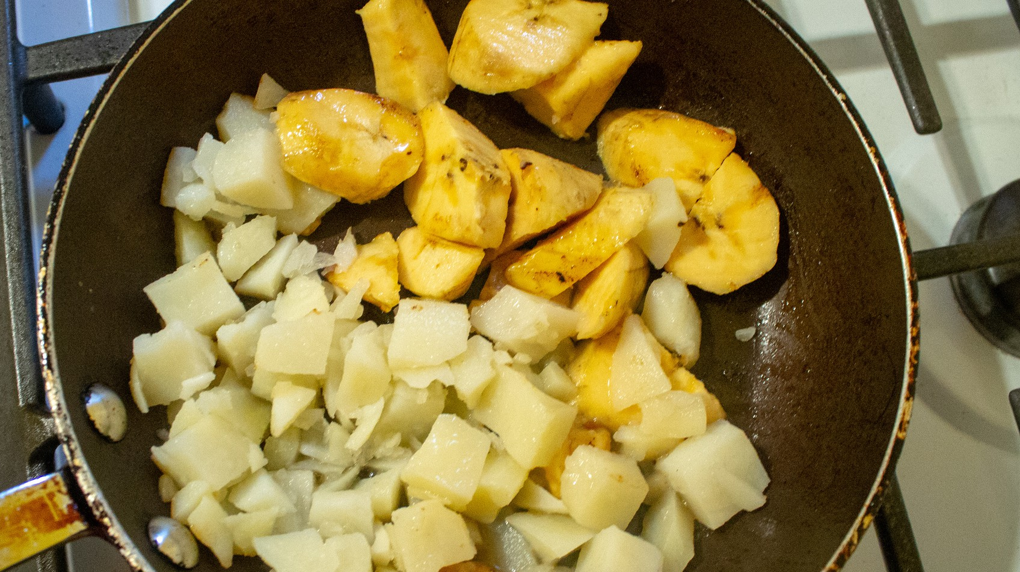

***EGGS, POTATO + PLANTAIN***

**COOK TIME: 1HR / SERVINGS: 2**

4 Potatoes 1tsp Salt

1tbsp Demerara sugar 6 **Eggs**

6 tbsp Olive oil 1 Red onion

1 tin of chopped tomatoes



Vegetarian

friendly

Super Saver

Recipe

Going Global

recipe

1 Scotch bonnet (optional to add spice)

Seasoning: all purpose, paprika, ginger, turmeric, thyme

1 Plantain (optional side dish)

**How to cook**

**Eggs + potatoes Plantain**

1. Firstly, peel and cut the potatoes into quarters. Wash the potatoes before placing in a large pot with water to cover, sugar and salt and setting on a high heat. Once they have been brought to a boil, place the potatoes on the lowest heat and prepare other ingredients.
2. Finely chop the red onion and scotch bonnet.
3. Beat the eggs until smooth and set aside for later.
4. Add the olive oil to a pan/wok and wait until it has been heated. The red onion, scotch bonnets and tinned chopped tomatoes should now be added to the pan/ wok along with all the seasonings listed in the ingredient list. Allow this to cook for roughly 5-10 minutes before adding the beaten eggs to the pan.
5. Allow the eggs to settle into the other ingredients before mixing together. The outside edge of the mixture showing bubbles indicates the egg is beginning to cook. Using a spatula, slowly push the mixture from the outside edge into the centre and repeat until you have gone round the whole pan and have pushed each part into the centre. The egg should become more solid. Flip the eggs regularly until cooked to desired consistency.
6. Once potatoes are cooked (soft when a knife is placed in the centre), drain them using a sieve.
7. The potatoes and egg are ready to be plated up!

**Per serving**

**Egg + Potato Plantain**

**kcal**

**704**

**228**

**fat**

**35g 13.8g**

**saturates**

**8g 2.05g**

**carbs**

**71g 28.5g**

**sugars**

**18g 13.5g**

**protein**

**28g 1.15g**

**Nutritional Info**

**To book onto our cookery sessions + other events visit**

**ehu.ac.uk/studentlifeportal**

1. Pour oil into pan and set to a high heat.
2. Peel the plantain and chop at a slanted angle into medium sized pieces.
3. Sprinkle a dash of salt onto the plantain and mix them around in a bowl. Carefully place them into the pan, allowing each side to be cooked to the desired colour- turning each piece over throughout the process to keep from burning.
4. Serve and enjoy with your eggs + potatoes!

|  |  |  |  |  |  |  |
| --- | --- | --- | --- | --- | --- | --- |
|  |  |  |  |  |  |  |
|  |  |  |  |  |  |  |
|  |  |  |  |  |  |  |

# Ingredients

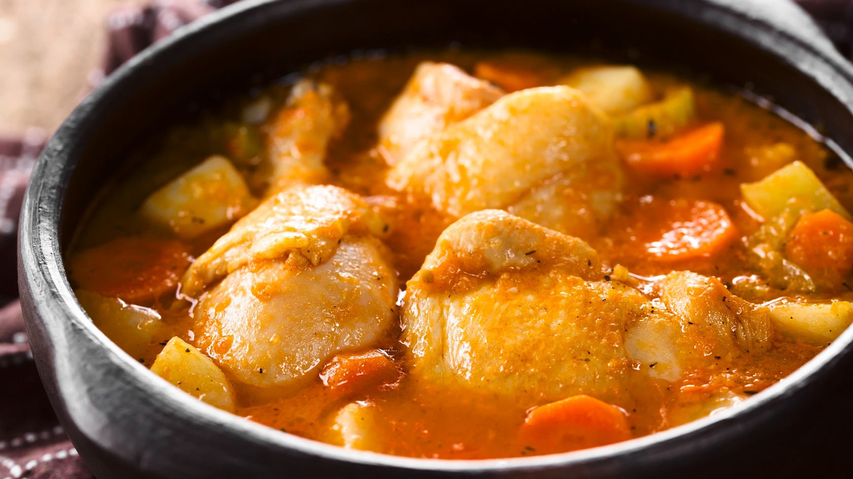

***CHICKEN GHOULASH***

**COOK TIME: 1HR15MINS / SERVINGS: 6**

1 tbsp vegetable oil

2 brown onions

3 cloves of garlic 2 carrots

2 parsnips 500g potatoes

4 red bell peppers 1 tomato puree

½ tsp salt

¼ tsp pepper 2 tsp paprika

½ tsp ground cumin (optional) 2 bay leaf

1 **egg**

200g plain flour

500g skinless chicken thigh fillets



Going Global

recipe

Super Saver

Recipe

Communal

bake

1. Dice onions, carrots, peppers and garlic and halve or quarter the potatoes. Then heat the oil in a stew pan.

**How to cook**

1. Once hot, add diced onions and cook over low heat for about 3- 5 minutes until soft and translucent and just beginning to turn golden.
2. Add the chicken thighs and cook for 5 minutes over medium heat until white/golden.
3. Add the salt, pepper, and pull away the pan from the heat. Add the paprika at this point, to avoid a bitter, burnt taste.
4. Remove the chicken from the pot with a slotted spoon and set it aside in a bowl.
5. Add the minced garlic, diced carrots, peppers, and tomato puree. Boil the water in the kettle then add the water to cover the stew ingredients.
6. Add the bay leaf and cumin.
7. Cook over a medium heat until the vegetables are medium softened, also fork-tender.
8. Then re-add the chicken you took out earlier and also the potato, cook for around 10-15 more minutes or until the ingredients are soft.

**Per serving**

**Chicken Goulash**

**kcal**

**453.31**

**fat**

**12.2g**

**saturates**

**2.7g**

**carbs**

**60.9g**

**sugars**

**15.7g**

**protein**

**31.1g**

**fibre**

**9.9g**

**Nutritional Info**

**To book onto our cookery sessions + other events visit**

**ehu.ac.uk/studentlifeportal**

|  |  |  |  |  |  |  |  |
| --- | --- | --- | --- | --- | --- | --- | --- |
|  |  |  |  |  |  |  |  |
|  |  |  |  |  |  |  |  |

**Ingredients**

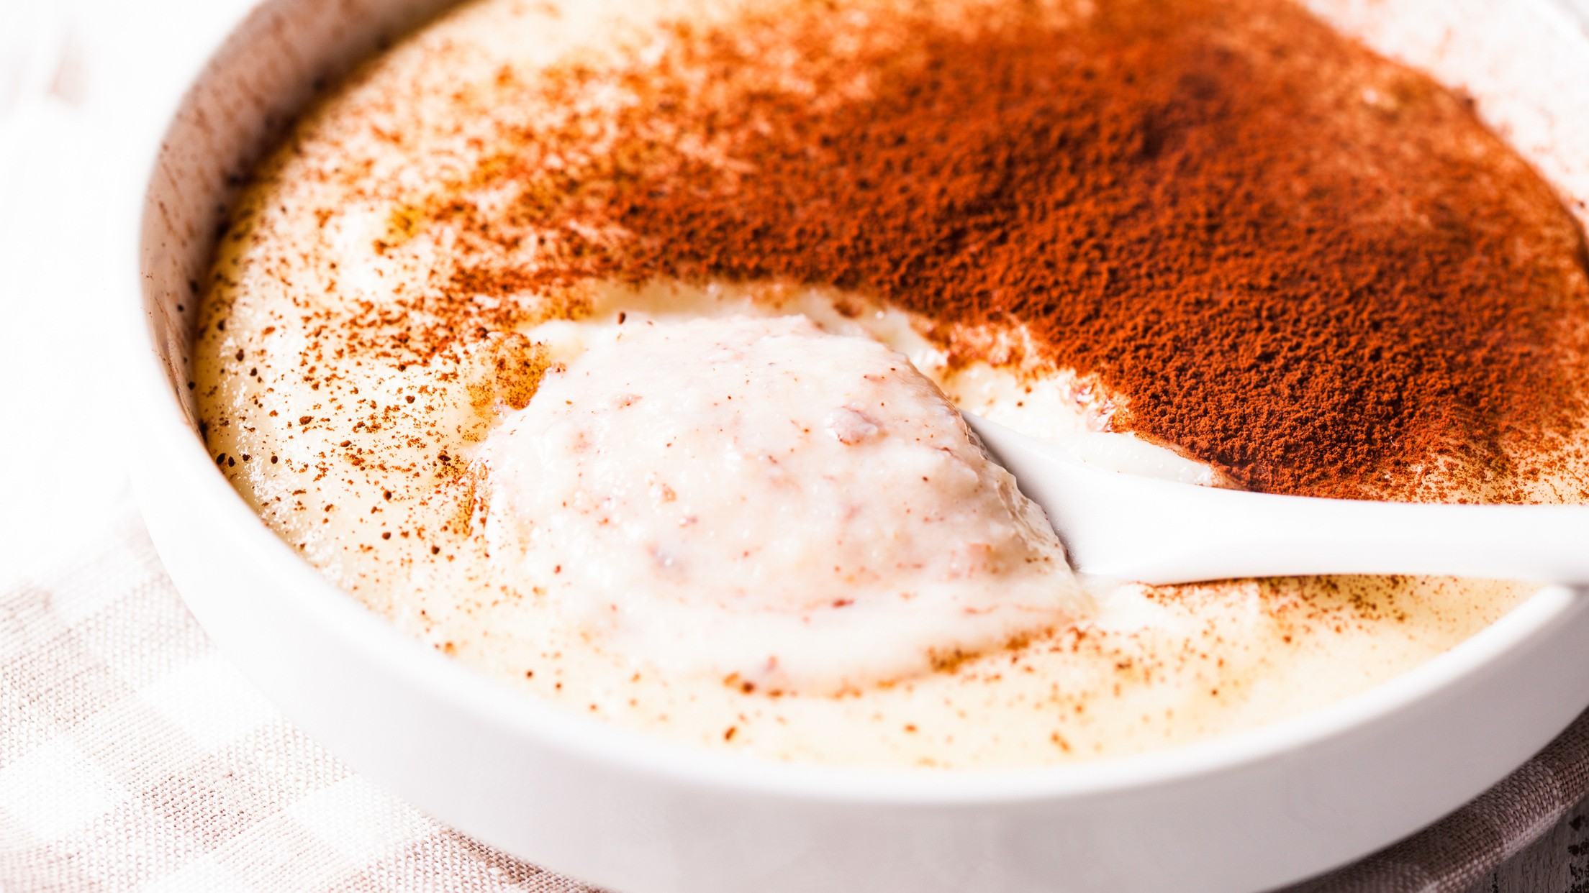

***SEMOLINA CREAM***

**COOK TIME: 15MINS / SERVINGS: 2**

500ml whole **milk** (can use oat/almond/coconut milk if you prefer) 2 tsp brown sugar

1 sachet of vanilla sugar (optional) 8 tbs semolina

You can use

non-dairy milk

Super speedy

recipe

Going Global

recipe

* 1. Wet a medium pot with two tablespoons water to prevent scorching, then add milk and heat on medium-high.

**How to cook**

* 1. Whisk the semolina into the milk, start cooking and stir to avoid any lumps forming.
  2. Continue stirring with a wooden spoon and cook slowly until it thickens. It will be ready when during stirring you see the bottom of the pot.
  3. Add the sugar and give it another stir.
  4. Then serve with cocoa or cinnamon dust on the top. You can add you favourite seasonal fruits as well.

**Per serving**

**Semolina Cream**

**kcal**

**427.8**

**fat**

**10.08g**

**saturates**

**5.7g**

**carbs**

**31.1g**

**sugars**

**26.5g**

**protein**

**14.9g**

**fibre**

**1.7g**

**Nutritional Info**

**To book onto our cookery sessions + other events visit**

**ehu.ac.uk/studentlifeportal**

|  |  |  |  |  |  |  |  |
| --- | --- | --- | --- | --- | --- | --- | --- |
|  |  |  |  |  |  |  |  |
|  |  |  |  |  |  |  |  |

# Ingredients



***GINGERBREAD***

**COOK TIME: 45MINS / SERVINGS: 10**

230g Plain **flour**

100g soft brown sugar 110g golden syrup Pinch salt

1tsp bicarbonate of soda

1 heaped tsp ground ginger

¾ tsp cinnamon 80g unsalted **butter**



Vegetarian

friendly

Sweet

treat recipe

Communal

bake

1. Pre-heat the oven to 180°C (approx. gas 5) and grease 2 large baking trays.

**How to cook**

1. Mix together the flour, sugar, salt, bicarbonate of soda, ginger and cinnamon in a bowl.
2. Add the golden syrup and the butter and mix together well until it forms a soft workable dough (if it is too crumbly you can add a little more butter, or if it is too sticky add a little more flour).
3. Roll out the dough on a lightly floured surface to about 1cm thick and use a cutter of your choice to cut them into shapes.
4. Lay out the shapes on the baking trays allowing a little room for them to expand.
5. Cook for around 10-15 minutes depending on how chewy you want them (the longer time the harder they will be).
6. Serve and enjoy!

**Per serving**

**Gingerbread**

**kcal**

**150**

**fat**

**5g**

**saturates**

**3g**

**carbs**

**23g**

**sugars**

**12g**

**protein**

**2g**

**fibre**

**1g**

**Nutritional Info**

**To book onto our cookery sessions + other events visit**

**ehu.ac.uk/studentlifeportal**

|  |  |  |  |  |  |  |  |
| --- | --- | --- | --- | --- | --- | --- | --- |
|  |  |  |  |  |  |  |  |
|  |  |  |  |  |  |  |  |

# Ingredients

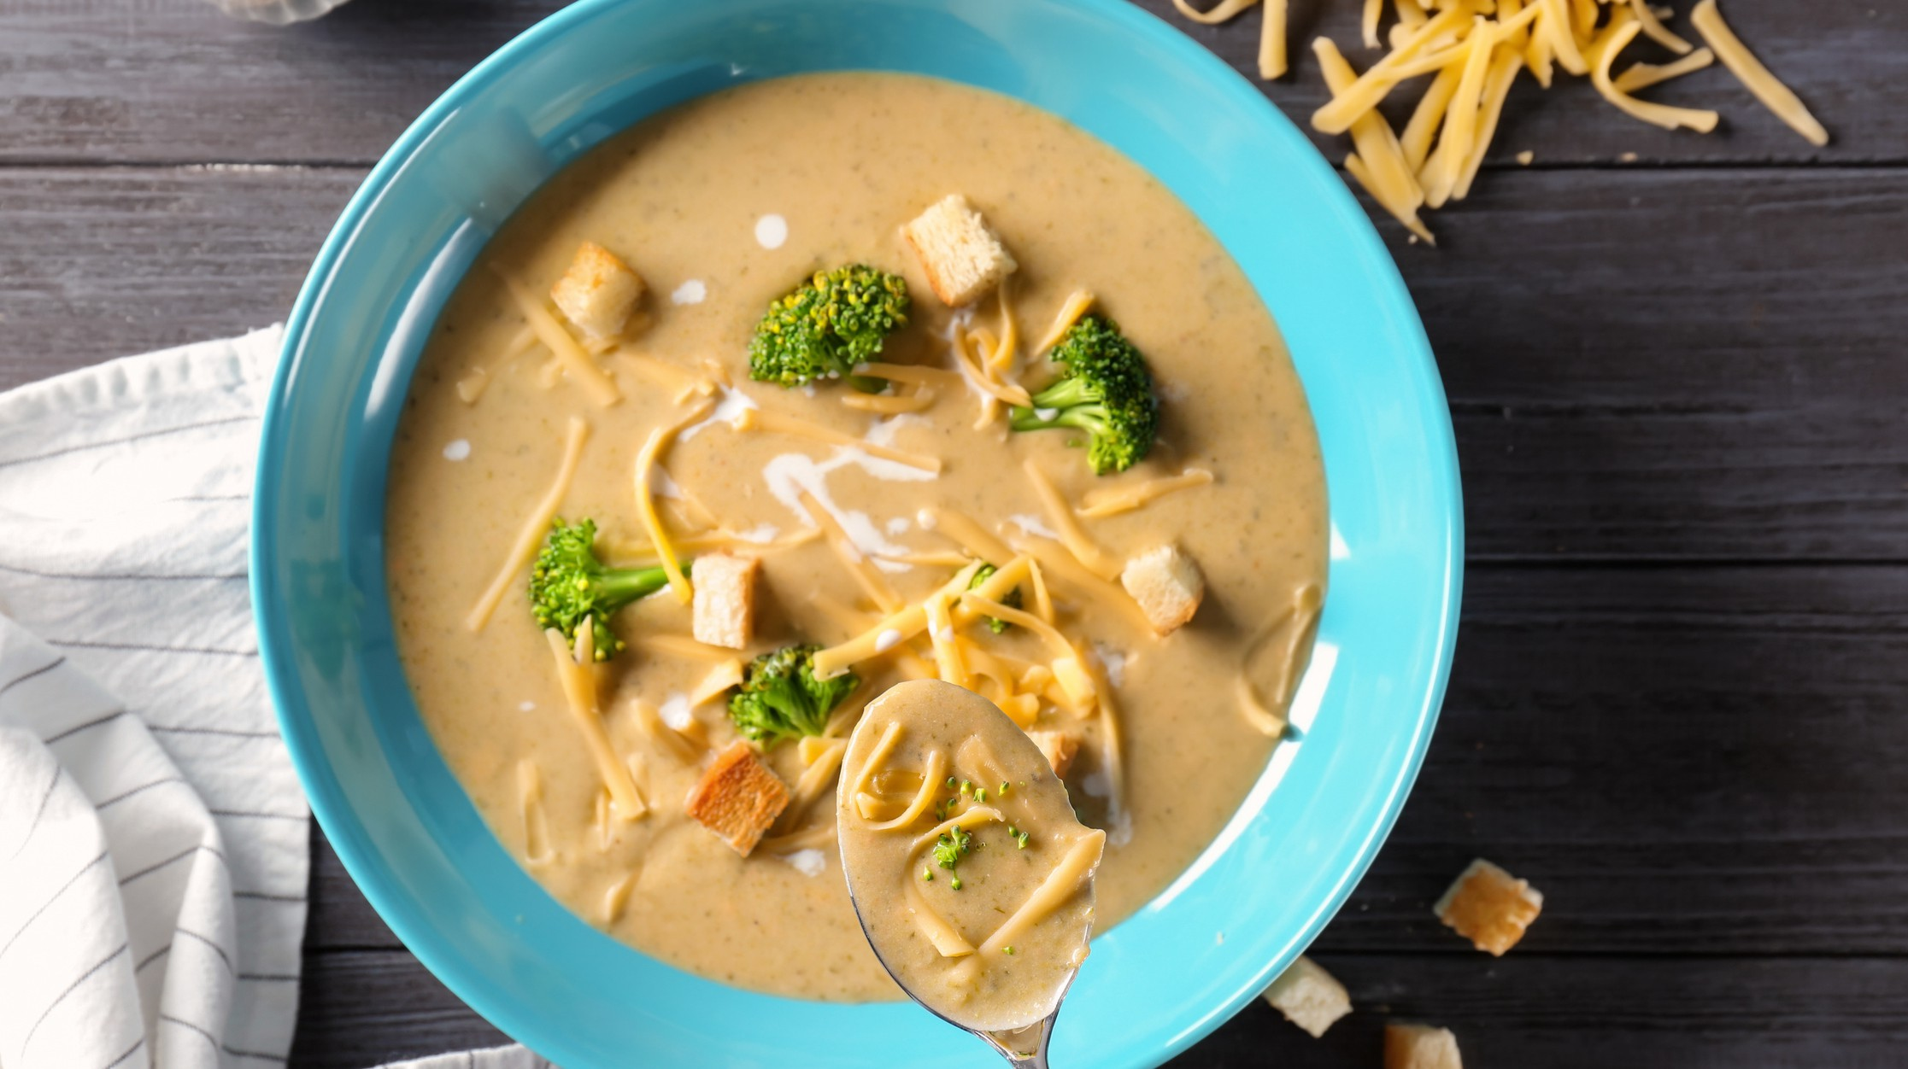

***BROCCOLI CHEDDAR SOUP***

**COOK TIME: 45MINS / SERVINGS: 2**

1 tbsp vegetable oil

1 garlic clove, crushed

4 spring onions, sliced, some of the sliced green bits reserved to garnish

1 small baking potato, washed and chopped

200g broccoli, stalk and florets separated and chopped (or frozen broccoli)



Vegetarian

friendly

Winter Warmer

Recipe

Communal

bake

½ vegetable stock cube, made up to 400ml

20g baby spinach 100ml **milk**

40g mature **Cheddar**, grated Toasted bread (optional)

1. Heat the oil in a large saucepan over a medium heat. Fry the garlic and most of the spring onions for 2-3 mins until softened (reserve some of the green parts).

**How to cook**

1. Add the potato and broccoli stalk to the pan and pour in the stock. Cover and cook for 10-12 mins until the potato is beginning to soften.
2. Add the broccoli florets and cook for another 5 mins until tender. Remove from the heat and stir through the spinach until wilted.
3. Use a handheld stick blender to mix the soup to a smooth consistency. Return the pan to a low heat and stir through 50ml milk and half the cheese. Heat for 1-2 mins until the cheese has fully melted. Add more milk to loosen the soup if needed.
4. Divide between bowls. Serve with toasted bread, cut into triangle shapes. Top the soup with the reserved spring onion and cheese to garnish.

**Per serving**

**Broccoli Soup**

**kcal**

**244**

**fat**

**11g**

**saturates**

**6g**

**carbs**

**24.4g**

**sugars**

**6g**

**protein**

**14g**

**fibre**

**5.8g**

**Nutritional Info**

**To book onto our cookery sessions + other events visit**

**ehu.ac.uk/studentlifeportal**

|  |  |  |  |  |  |  |  |
| --- | --- | --- | --- | --- | --- | --- | --- |
|  |  |  |  |  |  |  |  |
|  |  |  |  |  |  |  |  |

# Ingredients

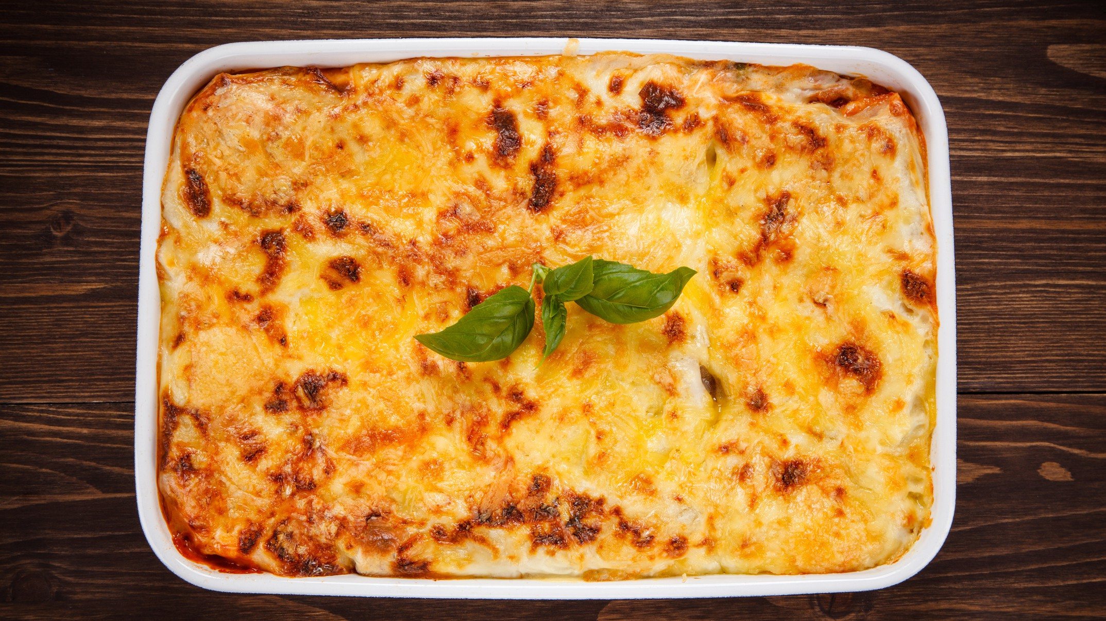

***COSY LASAGNA***

**COOK TIME: 1HR20MINS / SERVINGS: 4**

**For the ragu**

3 tbsp olive oil 1 carrot, diced

1 **celery** stick, diced (optional) 750g minced beef

200ml beef stock

2 x 400g cans chopped tomatoes 2 tbsp tomato puree (paste)

2 tbsp dried mixed herbs

**For the white sauce**

50g **butter** 50g plain **flour** 750ml **milk**

75g extra mature cheddar **cheese**, grated

2 tsp wholegrain **mustard** (optional) Salt and pepper

**To assemble**

10-12 **lasagna sheets**

20g extra mature cheddar **cheese**, grated

Fresh basil (optional)



Winter Warmer

Recipe

Super Saver

Recipe

Communal

bake

1. Heat the oil in a large pan over a medium heat. Stir-fry the carrot and celery, if using, for 3-4 minutes. Add the minced beef and continue to fry for another 5 minutes or until all of it is nicely browned. Season with a little salt and pepper.

**How to cook**

1. Pour in stock and the chopped tomatoes, followed by the tomato puree and mixed herbs. Bring to the boil and simmer for around 30 minutes until the sauce has thickened.
2. Preheat the oven to 200° fan/ 220°/425°F.
3. For the white sauce, add the butter, flour and milk to a saucepan and place over a low heat. Immediately begin stirring with a wooden spoon and do not stop until it has transformed into a thick sauce. Make sure that you are scraping the bottom of the pan, this is to prevent the flour sticking and burning.
4. Remove from the heat and throw in the grated cheese. Season with salt and pepper to taste.
5. Grab a baking dish, about 30 x 20cm / 12x8 in tin and layer in the ragu, white sauce then lasagne sheets, then repeat with another layer of each. Finish with a final layer of white sauce, making sure you don’t leave any gaps.
6. Finally, sprinkle the cheese over the top and bake in the oven for 30-40 minutes until golden brown on top.
7. Place the shop bought garlic bread into the oven for the instructed time before the lasagne is ready. Then serve and enjoy!

**Per serving**

**Lasagna**

**kcal**

**480**

**fat**

**19g**

**saturates**

**11g**

**carbs**

**21g**

**sugars**

**11g**

**protein**

**37g**

**fibre**

**2g**

**Nutritional Info**

**To book onto our cookery sessions + other events visit**

**ehu.ac.uk/studentlifeportal**

|  |  |  |  |  |  |  |  |
| --- | --- | --- | --- | --- | --- | --- | --- |
|  |  |  |  |  |  |  |  |
|  |  |  |  |  |  |  |  |

# Ingredients

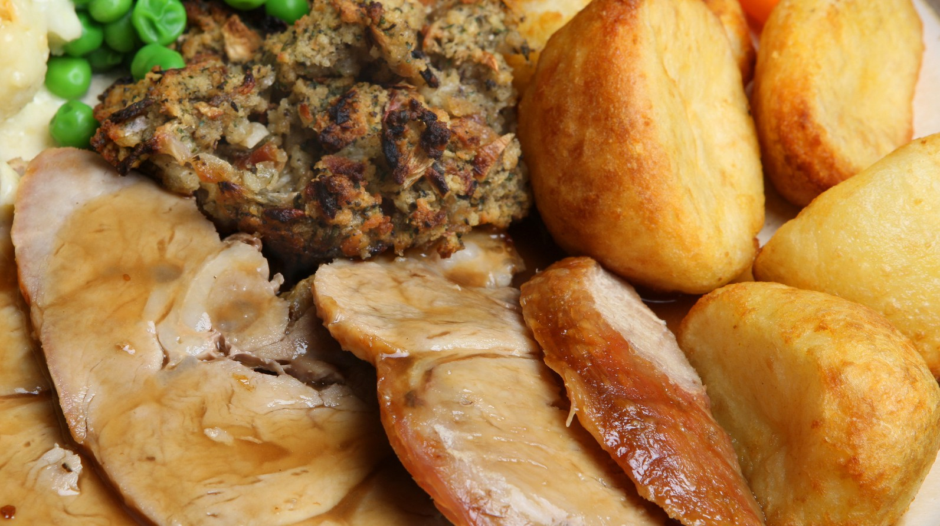

***ONE TRAY ROAST DINNER***

**COOK TIME: 1HR40MINS / SERVINGS: 1**

1 medium peeled baking potato 1tbsp oil

1 medium peeled parsnip

2 chicken thigh fillets

2 rashers of bacon

3 frozen stuffing balls 40g frozen peas

40g sweetcorn

1 frozen Yorkshire pudding 1tbsp chicken gravy granules



Winter Warmer

Recipe

Super Saver

Recipe

Vegetarian

friendly - use meat substitutes

1. Preheat the oven to gas 7, 220°C, fan 200°C.

**How to cook**

1. Boil a pan of salted water and add in the potato. Boil the potato for 10-12 minutes and then drain the water. Leave the potato to one side and leave it to dry for 1 minute.
2. Once dried, cut the potato into 2-3 pieces. Use a colander to then shake and roughen up the sides of the potatoes.
3. Heat the oil in a baking tray in the oven for 5 mins then add potatoes and parsnips. Roast in the oven for 20 minutes and toss occasionally.
4. Wrap chicken thighs in 2 rashers of bacon and add it to the baking tray containing the potatoes and parsnips, along with the stuffing balls. Roast for 35-40 minutes and rotate occasionally. The chicken should be cooked throughout and the potatoes golden and crisp.
5. Add the peas, sweetcorn, and Yorkshire pudding to the tray for the final 10 mins of cooking.
6. Once the roast is cooked, measure the gravy granules into a jug and top up with 150ml boiling water, stirring until smooth. Serve the roast with gravy poured over the top.

**Per serving**

**One Tray Roast Dinner**

**kcal**

**1200**

**fat**

**56.2g**

**saturates**

**14.6g**

**carbs**

**102.4g**

**sugars**

**8.9g**

**protein**

**68.5g**

**Nutritional Info**

**To book onto our cookery sessions + other events visit**

**ehu.ac.uk/studentlifeportal**

|  |  |  |  |  |  |  |
| --- | --- | --- | --- | --- | --- | --- |
|  |  |  |  |  |  |  |
|  |  |  |  |  |  |  |

# Ingredients



***PUMPKIN CUPCAKES***

**COOK TIME: 50MINS / SERVINGS: 12**

175ml sunflower oil

175g light muscovado sugar 3 large **eggs**

1 tsp vanilla

200g grated pumpkin flesh 100g **dried mixed fruit**

1 grated orange zest

2 tsp cinnamon

200g self-raising **flour**



Winter Warmer

Recipe

Vegetarian

friendly

Communal

bake

1 tsp bicarbonate soda 200g full fat cream **cheese** 85g icing sugar

A drop of orange or green food colouring

Sprinkles (optional)

1. Pre-heat oven to 180C/160C fan/gas 4.

**How to cook**

1. Place 12 paper cake cases into a muffin tray.
2. Put the oil into a large mixing bowl. Add the sugar, eggs, and vanilla extract and mix until completely combined.
3. Next, add the grated pumpkin flesh, dried fruit mix and orange zest into the mixture.
4. Stir the mixture again and add in the cinnamon, flour, and bicarbonate of soda. Mix until completely combined for a final time (the consistency should be wet and runny).
5. Evenly split the mixture into the 12 paper cases.
6. Bake the cakes for 25 minutes. They should be firm but still spongey to touch.
7. Cool on a cooling rack until cupcakes feel cold.
8. For the icing, mix the cream cheese, sugar, and food colouring until it is smooth and combined. The icing should not be too runny and should still have some thickness. If you want different coloured icing on top, split the icing into two separate bowls and add the food colouring into each bowl.
9. Finally, spread or pipe the icing on top of the cakes either flat, or in a swirl. For an optional touch, add some sprinkles on top.

**Per serving**

**Pumpkin Cupcakes**

**kcal**

**361**

**fat**

**19.3g**

**saturates**

**4.7g**

**carbs**

**41.3g**

**sugars**

**28.6g**

**protein**

**4.9g**

**Nutritional Info**

**To book onto our cookery sessions + other events visit**

**ehu.ac.uk/studentlifeportal**

|  |  |  |  |  |  |  |
| --- | --- | --- | --- | --- | --- | --- |
|  |  |  |  |  |  |  |
|  |  |  |  |  |  |  |

# Ingredients

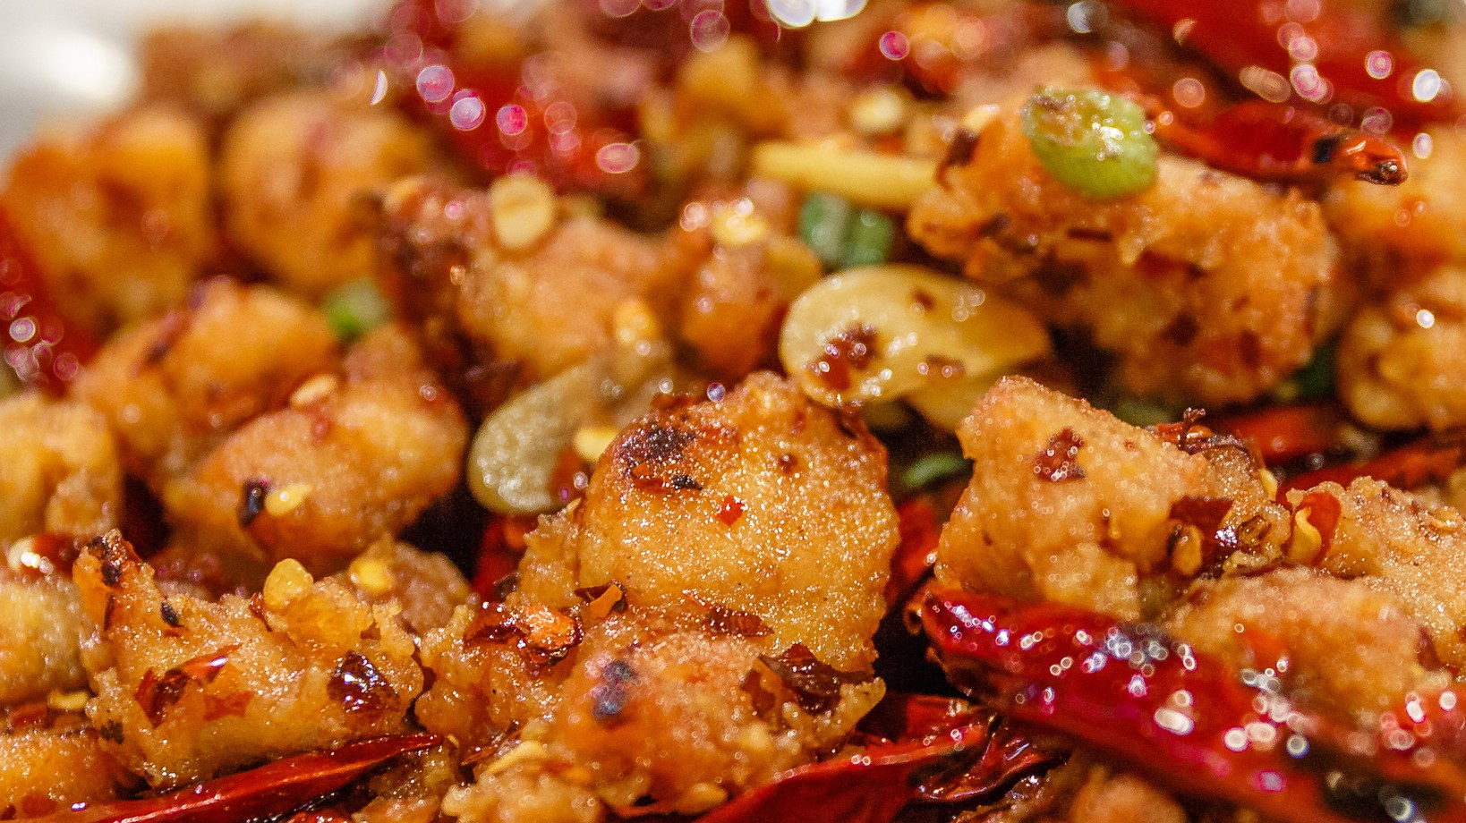

***SALT & PEPPER CHICKEN***

**COOK TIME: 40MINS / SERVINGS: 2**

250g chicken breast fillets, thinly sliced

100ml olive oil

2 tbsp garlic-infused oil

1 red bell pepper chopped 1 carrot, thinly sliced

¼ tsp dried chilli flakes 1 red onion thinly sliced

**For the seasoning**

½ tsp chinese five spice

½ tsp ground ginger

½ tsp black pepper

½ tsp salt

**For the coating** 90g cornflour 135g plain **flour**

1 tsp baking powder

¼ tsp salt 2 **eggs**

Going Global

recipe

Super Saver

Recipe

You can use

gluten-free flour

1. Preheat oven to 180°C fan / 200°C / 400°F.

**How to cook**

1. In a small bowl combine all the ingredients for the seasoning and place to one side.
2. Mix all the dry ingredients for the coating together in a large bowl. Crack the eggs into a medium-sized bowl and beat with a fork.
3. Add a third of the chicken slices to the dry ingredients bowl and toss until evenly coated, transfer to the egg bowl and toss again until evenly coated. Transfer them back to the dry ingredients until evenly coated and squeeze the chicken until the flour compacts as much as possible. Repeat these steps with the remaining chicken.
4. Add the olive oil to a large pan so that it fully covers the base. Place over a medium heat and, once heated, gently place your coated chicken into the oil in batches- it should sizzle. Once all the coated chicken is slightly golden remove and place on a baking tray. Put in the oven and turn every 10-15 minutes until the coating becomes golden and crispy, this makes the chicken super crunchy!
5. In a clean frying pan heat the garlic-infused oil in a large frying pan over a medium heat. Add the red pepper, carrot and onion and stir-fry for 3-4 minutes until slightly browned. Add in the cooked chicken and stir.

Sprinkle a third of the seasoning (don’t add it all as it won't give an even coverage), repeat until all the seasoning is used.

1. Serve with the egg fried rice.

**Per serving**

**Salt & Pepper Chicken**

**kcal**

**604**

**fat**

**51g**

**saturates**

**7g**

**carbs**

**4g**

**sugars**

**3g**

**protein**

**30g**

**fibre**

**1.5g**

**Nutritional Info**

**To book onto our cookery sessions + other events visit**

**ehu.ac.uk/studentlifeportal**

|  |  |  |  |  |  |  |  |
| --- | --- | --- | --- | --- | --- | --- | --- |
|  |  |  |  |  |  |  |  |
|  |  |  |  |  |  |  |  |